Changing the World:
Community, Science and Engagement with Big History

Symbiosis School for Liberal Arts, Symbiosis International University,
Viman Nagar, Pune, Maharashtra, India.

1st to 5th August 2021

Changing the World:
Community, Science and Engagement with Big History

Symbiosis School for Liberal Arts, Symbiosis International University,
Viman Nagar, Pune, Maharashtra, India.

1st to 5th August 2021

The International Big History Association’s Fifth Global Conference, in collaboration with SSLA, will be held in the summer of 2021 in India. Its theme focuses on Changing the World: Community, Science and Engagement with Big History. The IBHA has held conferences on meaning, teaching and research, and now addressws issues of community and change around our planet.

India is a powerhouse of innovative development, with cultural and intellectual traditions reaching back thousands of years. Symbiosis is an embodiment of this heritage and enterprise, a truly modern synthesis. Situated along the Mula-Mutha River, its nine campuses in the city of Pune lie on the Deccan Plateau, 600 meters above the Arabian Sea. Founded in 1971, it celebrates its Golden Jubilee this academic year, fifty years of changing lives in the world!

Symbiosis serves 30,000 students, who come from more than 85 countries, so, appropriately, its Sanskrit motto is वसुधैव कुटुम्बकम् – Vasudhaiva Kutumbakam – The World is One Family. The Symbiosis School for Liberal Arts (SSLA) is one of the university’s most innovative programmes. Launched in 2011, SSLA was the first liberal arts school in an Indian university and remains the only four-year degree and honours programme.

SSLA is home to the India Association for Big History (IABH), which formed in 2016. Two years later, the first course in Big History in South Asia began at SSLA, growing out of its Anthropology Department. Today, the course is taught as Humanity and Big History: Our Challenge for Survival and is a required course for all third-year students.

Other co-sponsors of the 2021 Big History conference are the Asian Big History Association, the Eurasian Center for Mega-History & System Forecasting, and the Indian Association for Big History, along with the seminar organizations.

Barry Rodrigue, Ph.D.
SSLA Professor, Anthropology
IBHA International Coordinator
<rodrigue@archinets.org>

Richa Minocha, Ph.D.
SSLA Associate Professor
Gender Studies & Ecology
<richa.minocha@ssla.edu.in>

Oishika Neogi
Student Coordinator
International Relations / Law
<oishika.neogi@gmail.com>

Sulakshana Sen, Ph.D.
Nrityangan Academy of Dance, Drama
& Music, Kolkata, West Bengal, India
<sulakshanasen@yahoo.co.in>

Conveners:
Anita Patankar, Ph.D., Director and Shweta Sinha Deshpande, Ph.D., Deputy Director
Symbiosis School for Liberal Arts, Symbiosis International [Deemed University]
Pune, Maharashtra, India <www.ssla.edu.in>.

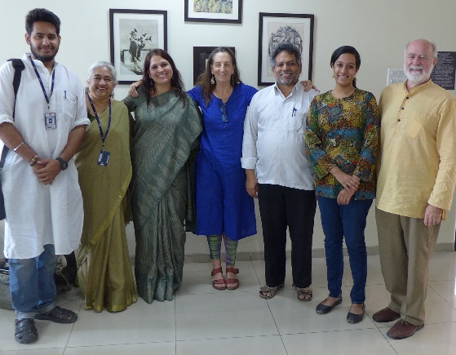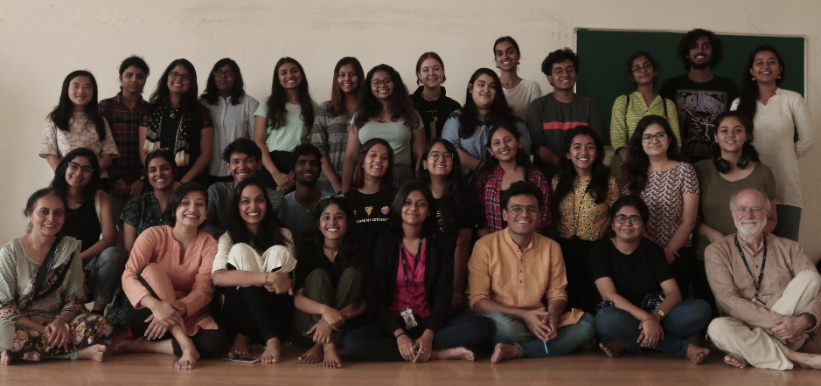

Contents

Arrival Days …………………………………………………………………….

Schedule ………………………………………………………………………...

Panel Abstracts …………………………………………………………………

Individual Abstracts …………………………………………………………….

Biographies ……………………………………………………………………..

Conference Formats …………………………………………………………….
Digital and in-person presentations

Displays and Special Events …………………………………………………….

Conference Logos ………………………………………………………………

SSLA Ecology / Carbon-Energy Offset Initiative ………………………………

Childcare and Kids Events ……………………………………………………...

Kachchh Patthar ………………………………………………………………..

Post Conference Seminars ……………………………………………………....

Conference Workers ……………………………………………………………

Arrival Days

31 July to 1 August 2021, Saturday and Sunday

Welcome to SSLA
Rest and Social Time

One of our SSLA team members will meet you at Pune International Airport, if you like. Your guide will take you to your room, where you can leave your luggage, then bring you to SSLA, where you can check-in and orient yourself to the campus. If you would like to be met at the airport or have any other arrival questions, please contact:

Barry Rodrigue at <rodrigue@archinets.org>

On Sunday, August 2nd, we will begin the conference programme with a tour of Pune, followed by the Inaugrual Session and an Orientation to India.

Sunday, 1 August 2021

9:00 AM to 2:00 PM
Meet at Gate 3, Symbiosis New Campus, Viman Nagar

Pune City Tour

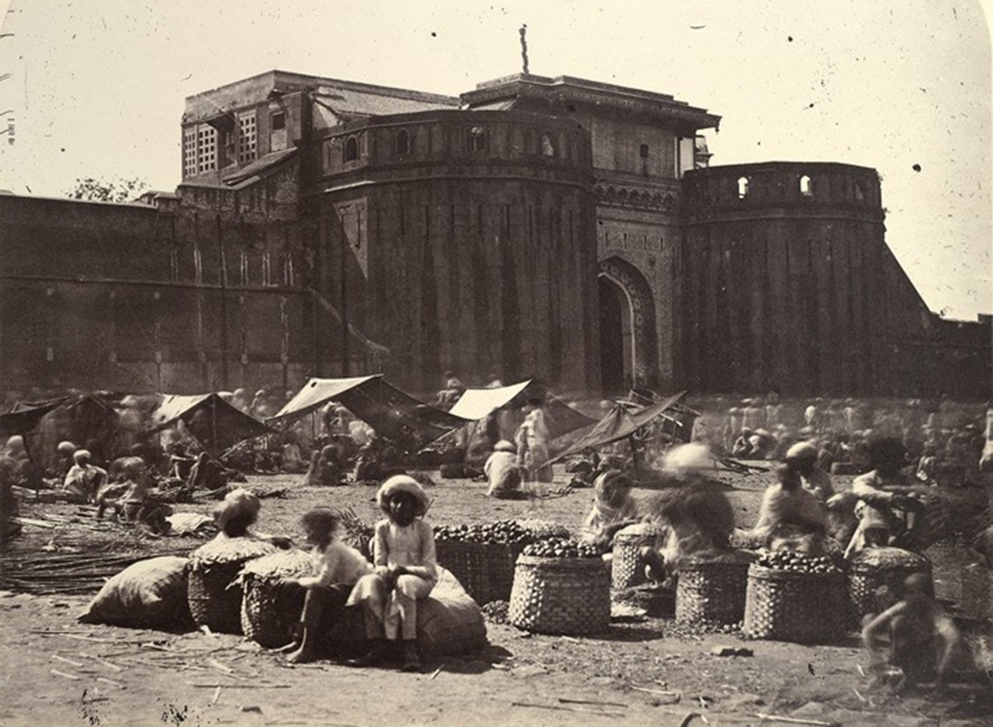
Shaniwarwada Fortress, c. 1865

A/C coach, organized by Shishir Nikam, Black Swan Journeys (Pune)
Conservation architect & historian for the tour
Art historian at Kelkar Museum
Maharashtran Lunch

4:00 to 5:00 PM
Symbiosis Old Campus, Viman Nagar – Auditorium

Inaugural Session

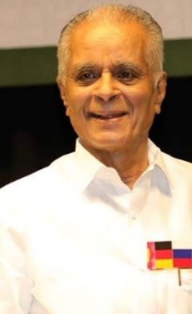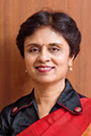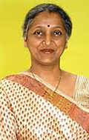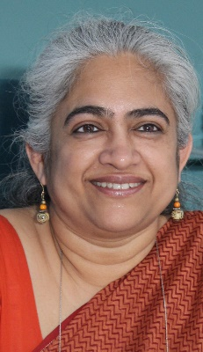

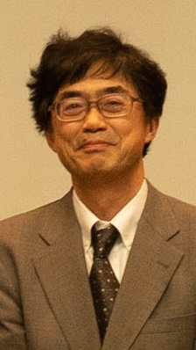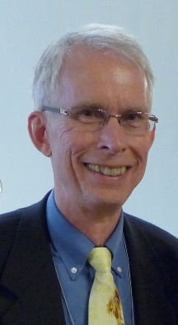

Oishika Neogi, The New School (USA), Moderator

•S.B. Mujumdar, Chancellor, Symbiosis International [Deemed University]
•Vidya Yeravdekar, Pro-Chancellor, Symbiosis International [Deemed University]
•Rajani Gupte, Vice Chancellor, Symbiosis International [Deemed University]
•Anita Patankar, Director, Symbiosis School for Liberal Arts
•Hirofumi Katayama, Vice Dean, College of Arts & Science, J.F. Oberlin University (Japan)
•Lowell Gustafson, President, International Big History Association (USA)
•Nubuo Tsujimura, President, Asian Big History Association (Japan)

***
Afternoon Tea
5:00 to 5:30 PM / Symbiosis Old Campus – Auditorium

***

Welcome to SSLA, India … and the Cosmos!
5:30 to 7:30 PM / Symbiosis Old Campus – Auditorium
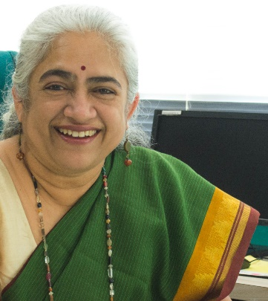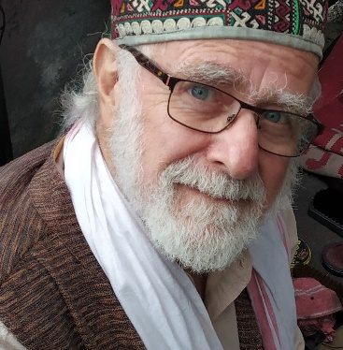
India, SSLA and the Cosmos
Anita Patankar, Director, SSLA, Pune, Maharashtra
Barry H. Rodrigue, SSLA, IBHA, ABHA, Pune, Maharashtra

***
Orientation to South and Central Asia

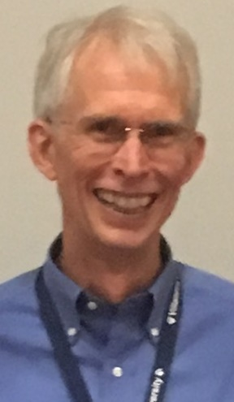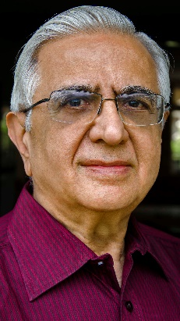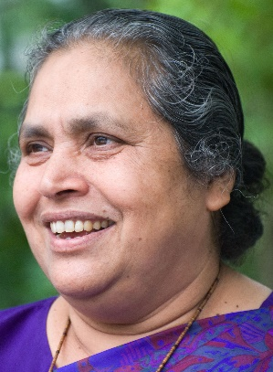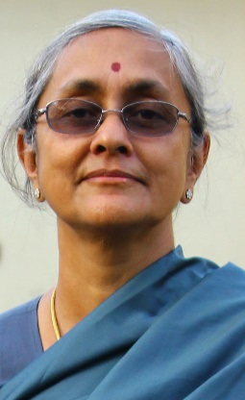

Lowell Gustafson, Moderator
Faculty, Villanova University, Villanova, Pennsylvania
President, International Big History Association

Kishan Rana
India: How Might Past Glory and Current Challenges Shape the Future?
Professor Emeritus, DiploFoundation
Diplomat and Ambassador (ret), Indian Foreign Service, Delhi

Lucy Kurien
Giving Life and Empowerment to India’s Dispossessed
Founder and Director, Maher Ashram, Pune, Maharashtra

Radhika Seshan
Community and Science in India: A Large Historical Perspective
Historian and Faculty, SSLA, and Head, Department of History (ret.),
Savitribai Phule Pune University, Pune, Maharashtra

Shweta Sinha Deshpande
Constructing the Present from the Past: Archaeology, History, Identity in India
Deputy Director and Faculty, SSLA, Pune, Maharashtra
Founding Co-Coordinator, Indian Association of Big History

***

Dinner and Conversations
7:30 PM
Symbiosis Old Campus – Ground Floor Terrace.

Monday, 2 August 2021

8:30 AM to 9:30 AM
Parallel Panels / SSLA Campus

9:45 AM to 10:45 AM
Parallel Panels / SSLA Campus

***

Tea / 10:45 AM
SSLA Campus – Rotunda

***

11:15 AM to 12:45 PM
Plenary Session 1 / SSLA Campus – Courtyard

Transforming the World: Visions of a Pluriverse
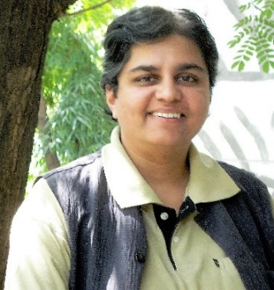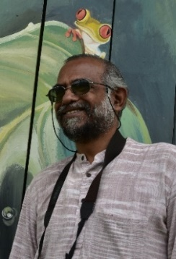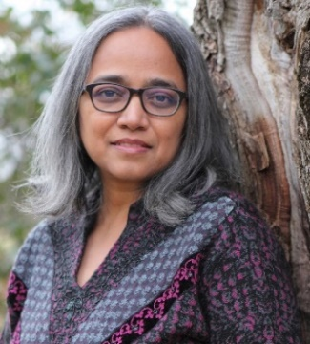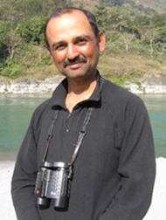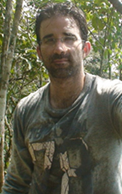
Priyadarshini Karve, Moderator
Big History Outlook on Human Sustainability
Faculty, SSLA, Founding Member, Indian Association for Big History
Director of Samuchit Enviro Tech, Pune, Maharashtra (India)

Ashish Kothari, Radical Ecological Democracy: Towards Justice and Sustainability
Kalpavriksh, Vikalp Sangam and Global Tapestry of Alternatives, Pune, Maharashtra (India)

Vandana Singh, Science, Imagination and Empowerment in an Entangled World
Author, New Delhi (India) / Scientist and Faculty, Department of Physics & Astronomy, Framingham State University, Massachusetts (USA)

Hem Sagar Baral, Community-Led Conservation in Nepal
Naturalist and Founder-President, Himalayan Nature
and The Nepalese Ornithological Union, Kathmandu (Nepal)

Carlos Londoño, The Anthropology of Morality
Faculty, Department of Anthropology, University of Regina, Saskatchewan (Canada)
President, Society for the Anthropology of Lowland South America

***

Lunch – 1:00 to 2:00 PM
SSLA Campus – Rotunda

***

2:15 to 3:15 PM
Parallel Panels / SSLA Campus

3:30 to 4:30 PM
Big History Author’s Roundtable
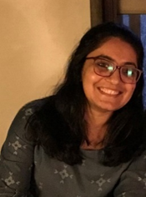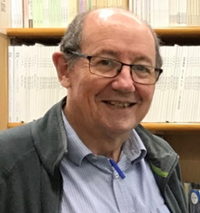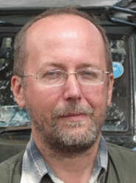
Afshan Majid, SSLA, Moderator

David Christian
Origin Story: A Big History of Everything, Boston: Little, Brown, 2018

David LePoire and Andrey Korotayev
The 21st Century Singularity and Global Futures: A Big History Perspective
New York: Springer International Publishing, 2020

Spencer Striker
History Adventures, World of Characters, Doha: History Adventures, 2020

***

Tea / 4:30 PM
SSLA Campus – Rotunda

***

6:00 to 8:00 PM
Plenary Session 2 / Symbiosis Old Campus – Auditorium

What We Are and Who We Are:
Yesterday, Today and Tomorrow
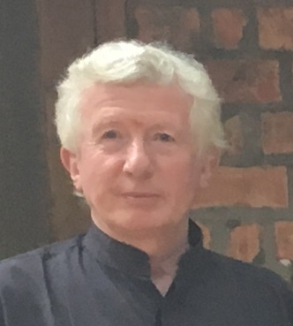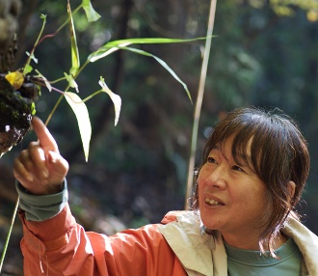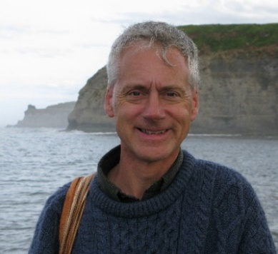
John Clammer, Moderator,
Fabrics of Being
Faculty, Kyoto University, Kyoto (Japan)

Nigel Hughes
Listening to the Past: Using Fossils as Storytellers
Faculty, Department of Earth & Planetary Sciences
University of California, Riverside (USA)

Masako Sakata, Harmony and Diversity: From Mt. Takao to the Universe
President, Japan Civil Network for the U.N. Decade on Biodiversity (2011–2020)
Nobuo Tsjimura, ABHA, translator

Shubhangi Swarup, Big History in the Time of Navel-Gazing
Author, Mumbai, Maharashtra (India)

***

Dinner and Conversations
8:00 PM – Symbiosis Old Campus – Ground Floor Terrace

Tuesday, 3 August 2021

8:30 AM to 9:30 AM
Parallel Panels / SSLA Campus

9:45 AM to 10:45 AM
Parallel Panels / SSLA Campus

***

Tea / 10:45 AM
SSLA Campus – Rotunda

***

11:15 AM to 12:45 PM
Plenary Session 3 / SSLA Campus – Courtyard

Managing Crisis in the World
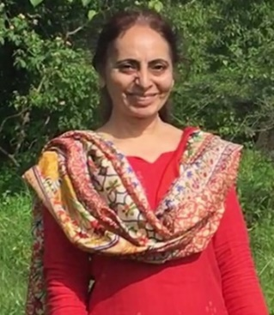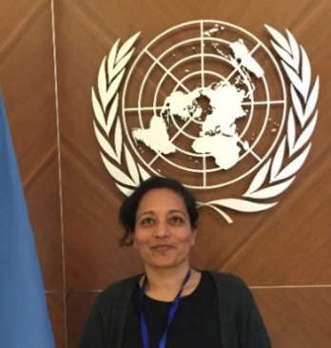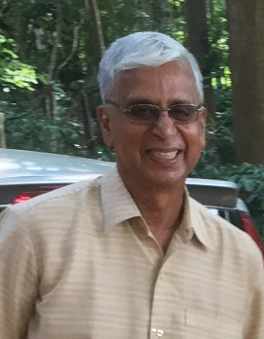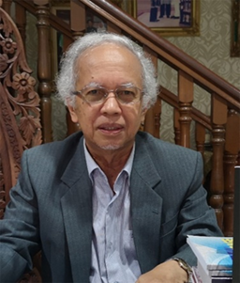
Richa Minocha, Moderator
Women, Social Ecology and New Visions
Faculty, Symbiosis School for Liberal Arts, Pune, Maharashtra and
Advisor, Society for People’s Initiatives, Simla, Himachal Pradesh (India)

Shobha Rao, Sustainability and Spiritual Considerations
Human Rights and Sustainability Consultant
Coordinator, Laxmi Krishna Trust, Bengaluru, Karnataka (India)

H. Sudarshan, Social Change and Social Continuum: Origins, Tribal Life and Big History
Secretary, Vivekananda Girijana Kalyana Kendra / Karuna Trust, Bangalore, Karnataka (India)

Shamshuddin Jusop, Changing Landscapes of Southeast Asia: A Big History of Survival
Faculty of Agriculture, University Putra Malaysia, Serdang, Selangor (Malaysia)

***

Lunch – 1:00 to 2:00 PM
SSLA Campus – Rotunda

***

2:15 to 3:15 PM
Parallel Panels / SSLA Campus

3:30 to 4:30 PM
Parallel Panels / SSLA Campus

***
Tea / 4:30 PM
SSLA Campus – Rotunda

***

6:30 to 8:30 PM
Plenary Session 4 / Symbiosis Old Campus – Auditorium

ReVisioning our World
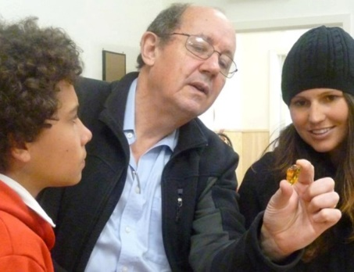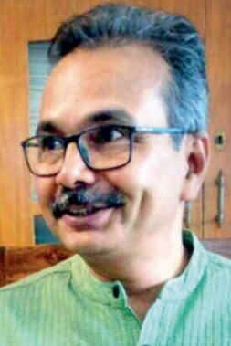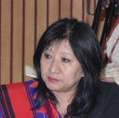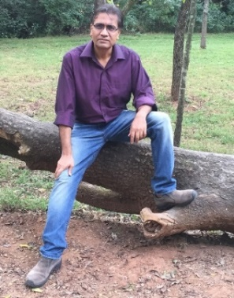
David Christian, Moderator
Learning to Manage a Planet
Faculty, Department of Modern History, Politics and International Relations, Macquarie University, Sydney (Australia) and Founding Board, International Big History Association

Nagarjuna Gadiraju, Halting-Actions: A Human Condition that Gives Access to Big History
Faculty, Tata Institute of Fundamental Research, Mumbai, Maharashtra (India)

Rosemary Dzuvichu, Women, Society and Rights
Faculty, English Department, Nagaland University, and
Advisor, Naga Mothers Association, Khomia, Nagaland

Anil Menon, Imaginative Resistance: What Stories Can and Cannot Do
Author and Computer Scientist, Pune, Maharashtra (India)

***

Dinner and Conversations
8:00 PM
Symbiosis Old Campus – Ground Floor Terrace

Wednesday, 4 August 2021

8:30 AM to 9:30 AM
Parallel Panels / SSLA Campus

9:45 AM to 10:45 AM
Parallel Panels / SSLA Campus

***

Tea / 10:45 AM
SSLA Campus – Rotunda

***

11:00 AM to 12:30 PM
Plenary Session 5 / SSLA Campus – Courtyard

Big History & Global Actions
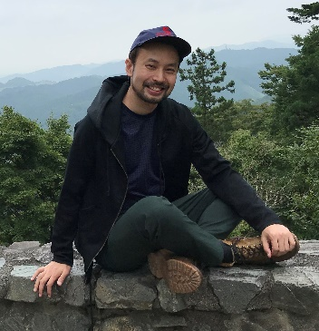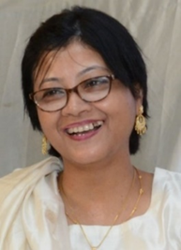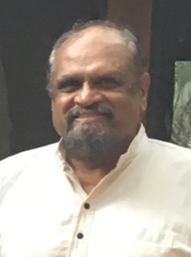
Nobuo Tsujimura, Moderator
Humanity’s Search for Meaning
President, Asian Big History Association, Tokyo (Japan)

Anjali Daimari, Tribal and Gender Rights among Global Peoples
Boro Women Justice Forum, Udalguri-Guwahati, Assam

Sun Yue, Compassion, Social Order and Equilibrium: History and Our New Needs
Faculty, Modern Languages / Editor, World History Centre
Capital Normal University, Beijing (China)

Siddhartha, New Thinking, New Actions
Fireflies Intercultural Centre, Bengaluru, Karnataka (India)

***

Lunch
12:30 to 1:30 PM
SSLA Campus – Rotunda

***

Rest and Tea
1:30 to 3:30 PM / SSLA Campus – Rotunda

***

4:00 to 8:00 PM
Symbiosis Old Campus – Auditorium

Creativity and Social Engagement

Sulakshana Sen, NADDM, Artist of Ceremony
Suchetana Banerjee, SSLA, Stage Manager

(Note: These events are being organized and added – a work in progress!)

Kachchh Ensemble
Kesariya Balama (Welcoming to our Land)

Bhuj, Kachchh, Gujarat

***

Ananya Parikh / Nikhil Narkar / SSLA Theatre

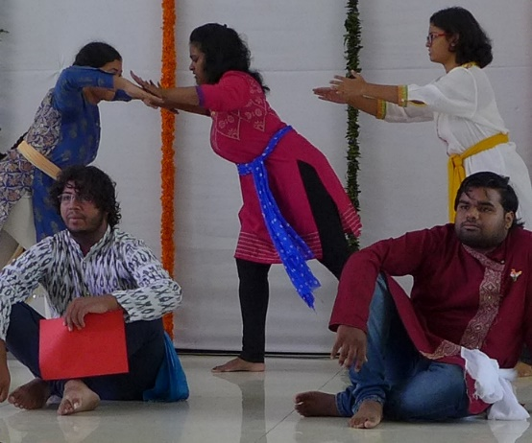

***

Roy Pereira
Songs of the Cosmos

Mumbai, Maharashtra

***

Speculative Futures: Fact and Fiction

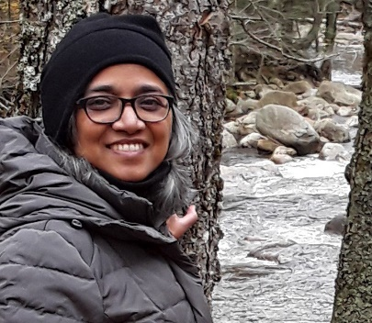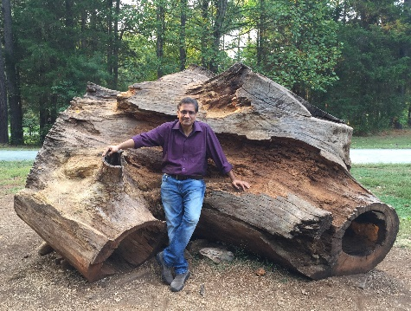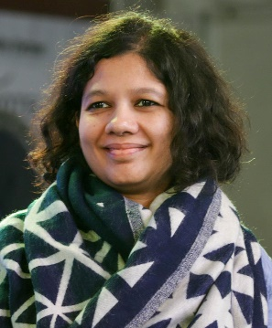

Vandana Singh, Moderator
Ambiguity Machines and Other Stories
Northampton: Small Beer Press, 2018

Anil Menon, Pune
Half Of What I Say
New Delhi: Bloomsbury India, 2017

Shubhangi Swarup, Mumbai
Latitudes of Longing: A Novel
Noida: HarperCollins India, 2018

***
Pallav Pandya, Mumbai
Changing the World: One Note at a Time

Keyboard performance with Pallav’s students

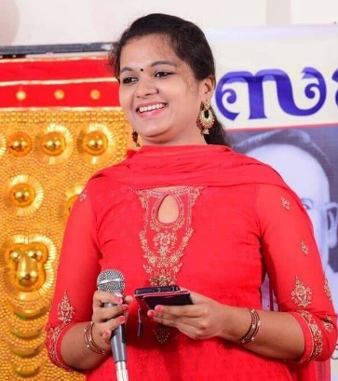

Sini G Nath
Bengaluru, Karnataka (India)

Swayam Mishra
Sargaj, Orissa (India)

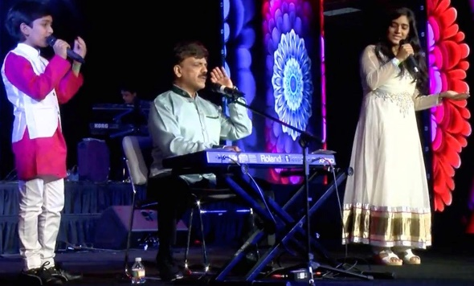
Varenyam, Pallav and Jahnavi Pandya
Jilo Jeevan Ji Bharke / Live Life at the Fullest

***

Kyohei Sakaguchi
Finding Hope in the World: The Zero Suicide Project

Kumamoto, Kyushu (Japan)

***

Yoshihiro Takishita
Kinship: Humanity and Nature in Shiguchi-do

Architect / Director, Association for Preservation of Ancient Japanese Farmhouses
Kamakura, Kanagawa (Japan)

***

Justin Scarimbolo
Music and Meanings / Soundscapes of Pune

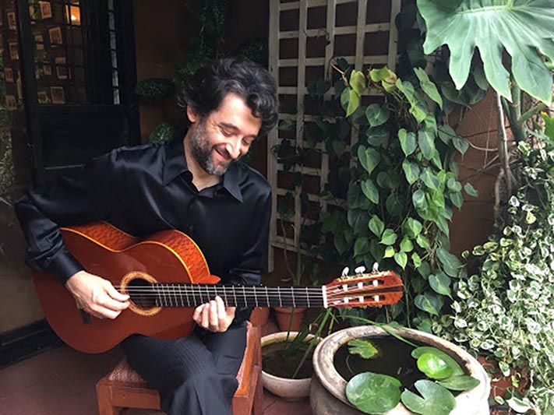

Ethnomusicologist, SSLA, Pune, Maharashtra, India

***

Chhatrapati Shivaji Maharaj Vastu Sangrahalaya
Society, Memory and Artefacts

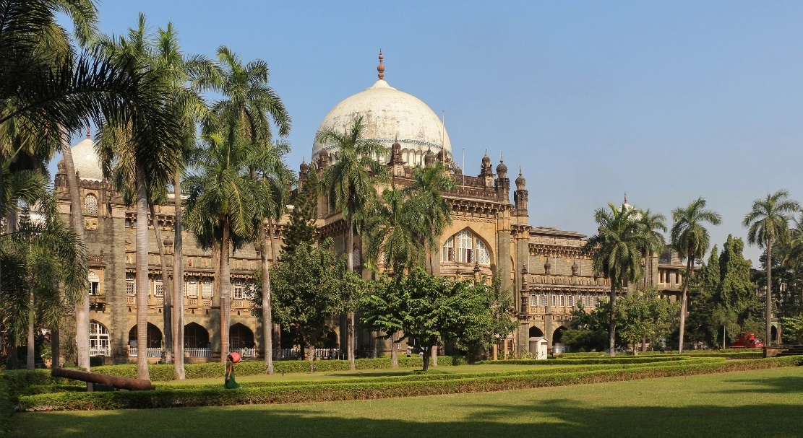

Chhatrapati Shivaji Maharaj Vastu Sangrahalaya
Mumbai, Maharashtra, India

***

Tea
5:30 to 6:00 PM
Symbiosis Old Campus – Ground Floor Terrace

***

Fossils and India’s Deep History

Nigel Hughes
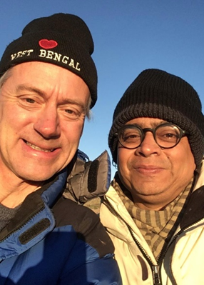
Reading from Monisha and the Stone Forest

Sekhar Mukherjee
Story-telling of whale evolution and the Subcontinent

***
Dinner and Conversations
8:00 PM
Symbiosis Old Campus – Ground Floor Terrace

Thursday, 5 August 2021

Roundtable: Big History Around the World
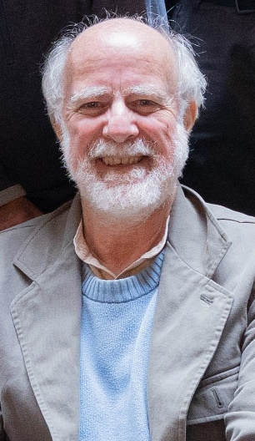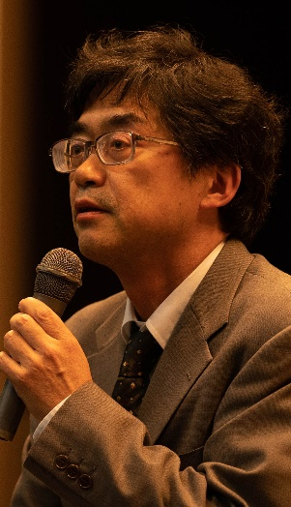
Barry Rodrigue, SSLA, IBHA, ABHA, Moderator

Hirofumi Katayama
Oberlin Big History Movement
J.F. Oberlin University, Tokyo (Japan)

Perpetua Bih
Government Bilingual Primary School
Bastos, Yaoundé (Cameroon)

***

IBHA / ABHA Panel
9:00 to 10:30 AM
SSLA Campus – MPH

The Futures of Big History
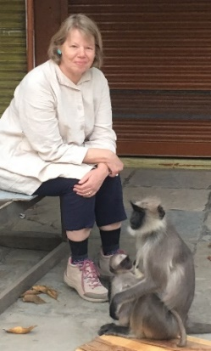
Moderators: Lucy Lafitte, IBHA and Nobuo Tsujimura, ABHA

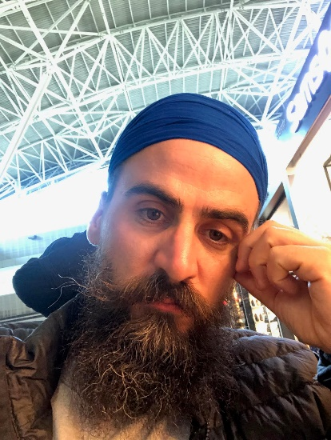
Mark Hartman, Brooklyn, New York (USA)

***

Tea
10:30 to 11:00 AM
SSLA Campus

***

IBHA / ABHA Members Meeting
11:00 to 12:30 AM
SSLA Campus – MPH

***

Lunch
12:30 to 1:30 PM
SSLA Campus – Rotunda

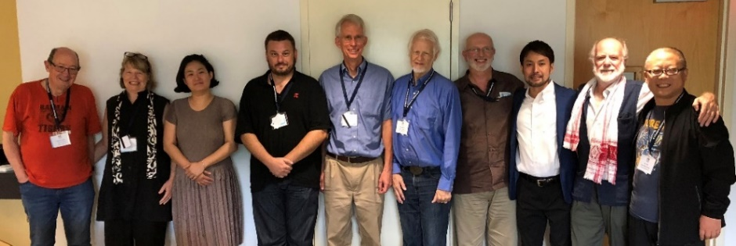

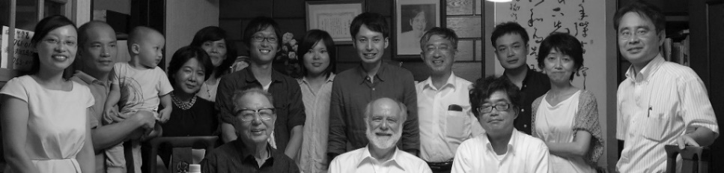

Panel Abstracts

Panel A
‘Meaning, Action and Narrative: Many Paths, One Goal’

How do we talk about what is meaningful in a scientific way? And in a way that makes space for other cultures and other viewpoints – even ones that may not share all of the modern, scientific assumptions about how the universe operates, what is real, what is not, what matters, and what doesn’t? This panel explores the limits of scientific objectivity in pursuing our shared goals of global enlightenment and environmental activism, as, for example, in the way we continue to craft our origin story. How do we work from within different traditions in pursuit of these aims without abandoning our scientific foundations? —Ken Baskin, David Blanks, D. Venkat Rao

Individual Abstracts

David Baker
The Taxonomy of Complexity: Deepening the Theory and Methodology of Big History

Big History weaves together the most up-to-date scientific and scholarly information into a narrative with a handful of key concepts. This presentation will discuss how to continue building Big History as a field of innovative scholarship and fresh investigations, as well as one that synthesizes the investigations of other fields. New data from novel scientific fieldwork will be revealed. The goal of this work is to transform the key concepts of Big History into a systematic and quantifiable set of scientific theories that will establish Big History as a unique and desirable area of study for people from the hard sciences and will assist scholars from the humanities to interpret the overarching trends of 13.8 billion years with greater clarity than ever before.

Daniel de Pinho Barreiros
Red Blood, White Flag: Archetypes, Evolution and a Big History of Warfare and Peace

Conventional historiography has harbored some important debates over hawkish and dovish approaches to war and peace, but rarely escaped from paying a heavy tribute to the moral and political philosophy of the seventeenth and eighteenth centuries. Naturally, this is not a problem per se, but when war and peace studies are faced with the play of scales endorsed by Big History, most of these studies’ conclusions appear as short-sighted. Big History transdisciplinarity empowers historians to question how phenomena in different timeframes interact to produce the reality we live in. Resorting to primatology and human evolution studies, on one side, and to complex psychology on the other, this work investigates the deep ethological / unconscious foundations of intersocietal coalitional violence, as well of prosociality and its interactions with culture and institutions. War and peace, in a deeper level, are products of behavioral phenomena created by the interaction between cognitive algorithms fixed by natural selection in some branches of the Primate order, in a Big History Threshold 5 context, while human cultural and narrative structures emerged after Threshold 6.

Ken Baskin
Thoughts on Healing the Damage Created by our Cosmological Crisis

Humanity stands on the liminal ledge separating a way of thinking of the world that no longer allows us to address our most serious challenges – the Newtonian worldview – and an emerging worldview that is only now becoming clear. While elements of this new worldview is developing in fields ranging from neurobiology to complexity science, judging from human history, the only way for it to replace its Newtonian predecessor is for it to become the cosmology of the 21st century, enhancing what biologist E.O. Wilson called the ‘evolutionary epic’ of the Universe’s story, starting with the Big Bang. This presentation examines David Christian’s challenge to complete this story, beginning with a definition of cosmology as the epistemology with which any society enculturates its people to meet its deepest challenges. It then examines the evolutionary epic in terms of its history and the unintended consequences that make it so difficult for us to address those problems today. Finally, this presentation will explore how reinvigorating the current narrative with the emerging worldview has the potential to enable humanity to step off its ledge and out into a new way of responding to challenges that often seem insoluble.

Benjamin Bishop
The Evolution of Language in Macrocosmic Terms

The evolution of language echoes that of biological entities at a number of levels, including the eventuality of change and the influence of external factors, from biome dynamics and society to weather and climate. This study proposes that the central tenets of Big History’s neo-Darwinistic approach to development of the universe show repeated elements, such as the inverse relationship between relative size and energy use. These tenets extend beyond the biological realm, as outlined in astrophysicist Eric Chaisson’s work in Cosmic Evolution. A linguistic example of this may be seen in the phonemic diversity of language as it spreads. This complexity may further be seen via understanding energy as an element of tonality, wherein greater entropy and energy use is apparent in languages with a smaller phonemic index. Further, fractal structures appear in the morpheme-like organization of languages at various levels. Taking these concepts into consideration, we see that a neo-Darwinian conceptualization of language is the result of grand processes that extends beyond the biological world to the wider universe.

David Blanks
The History of Disenchantment: Nietzsche, Jung and the Return of Apollo and Dionysus

When Nietzsche wrote in The Gay Science (1882) that ‘God is dead’, he was thinking about what sociologists Max Weber later called ‘the disenchantment of the world’, that is, the loss of meaning that came with the scientific overthrow of religious belief in the late nineteenth and early twentieth centuries. But as we in big history know, that search for meaning is alive and well, even among those scientists and historians who consider themselves thorough-going materialists. And indeed it is celebrated by many other big historians whether they are pantheists or monotheists. The point is that big history appeals to a wide variety of people with varying and often incompatible religious positions. By looking at the history of disenchantment through philosophy and psychoanalysis, this panel shows that the tensions we are finding within big history can be reconciled if we can learn to celebrate difference and accept that these seemingly opposing worldviews are needed if we are to reach the existential and environmental goals that we share.

Stephen Chundamthadam
Nature, Spirit, and the Search for Meaning:
A Pilgrimage to Gaumukh in the Himalayas

The history of the Himalayas and Mount Everest, the highest mountain in the world (8848 metres high) is part of Big History. About 80 million years ago, the Indian sub-continent which was closer to Australia, started moving towards the Eurasian plate. The eventual collision gave rise to the Himalayan mountain ranges. Because of the pressure of collision the Himalayas is still growing more than one centimeter per year. A pilgrimage to Gaumukh, situated at an altitude of 13,200 feet and at a distance of more than eighteen kilometers of trekking from Gangotri is an unforgettable life experience. The path is very narrow, risky, and often passes through the edge of steep mountain slopes. Warnings against landslides is displayed in several places. During winter, one can see only mountain after mountain covered with snow. My pilgrimage to Gaumukh was a divine experience guided by the Spirit, enjoying the beauty and grandeur of the great mountains and the nature.

David Christian
Learning to Manage a Planet

We live at a turning point in the 4.5 billion year history of Planet Earth. And it is human beings who are, collectively, changing everything. Suddenly, in my lifetime, we have acquired so much control over the biosphere that what we do in the next fifty years will shape the future for our descendants and millions of other species for millions of years. We have to learn very fast how to manage a planet, and manage it well! To do that, young people will need the wide-angle lens of Big History, because only on the scales of Big History can we see clearly what is happening on Planet Earth right now.

Anjali Daimari
Indigenous Women, Understandings, Rights and Contributions:
The Struggle for Boro Rights and Sovereignty

Indigenous communities represent a way of life that have often been not just ignored or forgotten by dominant societies but have been forced from their lands and brutally exploited. Throughout the world. Tribal knowledge and indigenous relations with each other and nature have the capacity to help solve many problems humanity faces today. The question is: How can we mutually survive on a rapidly changing planet? Tribal women in particular have faced assault, but they hold the reins of harmony in their hands. How can indigenous women make their visions of change happen? A significant answer to these questions lies in assuring the autonomy and self-determination of the indigenous, tribal communities and eliminating the injustices of class, gender and other biases. From a starting point of justice, then larger issues of mutual aid can be addressed. This broad discussion is addressed through the speaker’s long-time work as a Boro woman activist.

Shweta Sinha Deshpande
Constructing the Present from the Past: Archaeology, History and Identity in India

National identity uses the language of archaeology, history, and culture. The process is one of choice, which, by necessity, ignores many narrative details. The ‘Idea of India’ emphasizes a returning of the past to the people, but India’s identity has been contested since the early decades of the Freedom Struggle, a process that continues today. India and its people are connected and disconnected with each other and their geography through at least three broad strands of history. The first is the folklore history of the Puranas and Epics (Itihaas), a narrative first developed during British rule. The second is that of an immigrant and conquering tribe – the Aryan identity, which pushed the original inhabitants, the Dravida, to the southern part of the Subcontinent. This lead to a dual identity that grips political and cultural memories even now. The third, which is essentially archaeological, outlines a native evolution in the rise of cultures and communities from the Palaeolithic onwards. To this we can add genetic studies, which have yet to be fully assimilated by nationalists. Cultural scholars are often expected to explain: ‘Who are we?’ or ‘Where do we come from?’ as a people. But the past does not provide simple answers. I would rather change it to: ‘How did we become who we are?’ It is a form if inquiry that also resonates in Big History.

Imogene Drummond
Art Sparks: Igniting Creativity in a Big History Context

Art Sparks is a unique expressive arts programme that ignites individual inspiration in a Big History context. Designed for ages 8–12, it provides a bridge between creativity and personal growth. Through a focus on self-worth, ingenuity and the cosmos, the interdisciplinary curriculum results in increased student engagement, esteem, and empowerment. Art Sparks provides an awareness that an evolving dynamic happens all over the cosmos and is happening in each of us. It has demonstrated significant benefits in private and public classrooms in the United States and Italy since 2012. In this presentation, participants learn Art Sparks’ techniques, methodology and the key to its success, as demonstrated by a 10-year-old boy at San Miguel Academy in Newburgh, New York (USA). Through intentional acts of self-expression, he transformed so dramatically from an anxious loner to a warm, relaxed student – with significantly improved learning and social skills – that his teacher now calls him ‘the poster child for Art Sparks’ therapeutic results.’

Nagarjuna Gadiraju
Predominance of Halting Actions: A Peculiar Human Condition that Gives Access to Big History

What are the ontological and epistemic conditions of being Human that we could engage and speculate about big history? How could a part have cognitive access to the structure and dynamics of the whole? We engage with the above broad questions by conducting a grounded speculation about our roots in biological, cognitive and social layers of Being. In this narrative, we present an account of how halting habits, called memets, provide access to time (memory). The peculiarities of some of our habits, called memets, develop autonomy through syntactical disengagement, leading to a capacity to create and recreate traces (symbolizing), facilitating participation in a rule-based encoding and decoding (e.g., language). Through these cultural traces of memets we reconstruct a history of our own, called memetat. This haltin-action space provides access by involution of an otherwise evolving world.

Ken Gilbert
The Creative Power of Emerging Consciousness in an Awakening Universe:
Matter, Life, Mind, and the Future

This paper traces the manifestations of complexity and emerging consciousness from one stage to the next in the Big History narrative. It surveys some of the latest consciousness-related research along with a wealth of related studies across a variety of disciplines in the sciences and humanities. Big History has the opportunity to develop an interdisciplinary and overall evolutionary theory based on characteristic types of consciousness that can be seen emerging and empowering creative and transformative change at each origin event or threshold. This approach would be complementary to the revolutionary changes taking place in many fields. A perspective based on such a unifying theory illuminates the story from within, enhancing our understanding of the intimate connection between inner (consciousness) and outer aspects of an unfolding universe in the evolutionary process. It has potential to vastly broaden the scope of Big History.

Anton Grinin
Сrossing the Threshold of Cyborgization

Cyborgization is a widely discussed topic today. It is an intriguing process, which is still the subject of futuristic novels and at the same time is a reality. This paper discusses the development of cyborgization in the framework of the Big History, its background and future directions, as well as the problems and risks of this process.

Leonid Grinin
Evolution of the Early Solar System in Terms of Big History and Universal Evolution

The history and evolution of our early Solar System has long been a matter of great interest to humanity. In the past few decades, astronomers have considerably advanced our knowledge about its structure, history, and evolution. But one can hardly speak about a proper narrative; we more often are working with hypotheses. This paper outlines the history of the Solar System in the first hundred million years of its existence, when most of the major transformations took place. Then it shows how we can derive evolutionary laws and rules from this history. There are few consistent and brief surveys about the history of the Solar System that include the latest achievements in astrophysics and cosmology, so this descriptive history is itself novel. In addition, the evolutionary rules we derive from this history of the Solar System allow us to observe common features that are characteristic for each stage of Big History. This gives us the ability to conceive of the integrity of Big History and appreciate its ability to detect general laws, patterns, and mechanisms.

Lowell Gustafson
Coming of Age: Big History and Development

Historian David Christian has explained how Big History can serve as an origin story, answering the question of how we got here. Big History also can serve other important purposes, which can be considered as a coming of age story. It provides stories and explains processes providing a context for an individual’s maturation. One is associated with sexual maturity during puberty: To whom / to what am I attracted and why? Then there is the realization of our mortality, death, and extinction. What does it mean that I not only have an origin, but that I will have an ending? What does it mean that species, including my own, become or will be extinct? A third type is the realization of the independent existence of others and a self-conscious ability to relate to them as distinctly different than me. What does it mean that I am not the centre of the universe, or at least that everyone and everything else is also a centre? Big History has shown how Earth, life and humanity has led to me, but it has also led to every single other person, species, planet, galaxy, and maybe an infinite number of universes. To answer this, perhaps Big History needs to expand its purpose from the study of an ‘integrated history of the Cosmos, Earth, Life, and Humanity’ to other possible universes, galaxies, planets, and all life forms. What does it mean that much of the cosmos is going on without reference to humanity, and that it will do so long after we are gone?

Nigel C. Hughes
Listening to the Past: Using Fossils as Storytellers

In a time of rapid global environmental change, understanding how our planet responds to the profound changes induced by human activity is vital. We can approach this issue directly through a science-based understanding of the cause and effect governing physical and chemical systems, and we can test these ideas by looking into the Earth’s past history of rapid environmental change – a series of ‘natural experiments’ chronicled in the record of the Earth’s previous experience. This chronicle is the layers of sedimentary rock and the fossils they contain that are preserved all over the Earth. Ancient episodes of rapid global change were not human-induced, but nonetheless have important information to tell us about how our planet will respond in the present crisis. But to learn from the Earth’s past requires accepting that our science-based understanding is correct and that its history is real. Fortunately, over the last two centuries, we have acquired a tremendous wealth of data about the Earth’s past and its critical relevance to current issues. Earth’s history is dramatic, exciting, and truly wonderful. It is also profoundly relevant to making informed policy decisions. But this information should not be restricted only to those in positions of influence. Rather, our mission should be to share the profound story of the Earth’s past with all its current citizens. And those best placed to receive this story are those who are in contact with the Earth itself – particularly those citizens living in rural communities in which contact with the natural world is immediate. In recent years, a group of friends and I have been involved in scientific outreach in India and Bangladesh based on the Indian subcontinent’s unique and magnificent heritage of fossils. This has involved place-based stories that explain fossils and environmental change through published media, local-language outreach programs in educational centres, schools and madrasehs, and dramatic performances. We are expanding our scope, and planning to produce graphic novels and animation. This science-based history is one in which all citizens can experience wonder and pride. It is an essential part of our fleeting heritage as Earth’s inhabitants.

Shamshuddin Jusop
Changing Landscape of Southeast Asia: A Big History of Survival

The geology of Southeast Asia was relatively stable in the Quaternary period, from 2.6 million years ago to the present. One of the noticeable changes took place in coastal areas. The highest sea level in Southeast Asia was 50 meters above the present, while the lowest was 100 meters below it. A sea level drop about 40,000 years ago caused extensive erosion, resulting in riverine terraces that can be observed in Peninsular Malaysia, Thailand and Cambodia today. This marked change was not due geological movement. About 20,000 years ago, the Earth’s polar regions were covered by ice during the last glacial maximum. As the Earth’s temperature started to slowly go up during the following interglacial, a global sea level rise took place. The highest in Southeast Asia occurred during the Holocene epoch about 4300 years ago, when it was 3–5 meters above the present height. During that time, much of the low-lying areas on the seaside plains were flooded by sea water, which changed the mineralogy of the affected sediments. The drop in sea level that followed resulted in the formation of a series of sandy beach ridges of decreasing height, forming the conspicuous landscape of the coastal plains of the countries facing the South China Sea. By using a big history perspective, we see how the fluctuating sea level not only changed the littoral landscape, but affected soil fertility, agriculture production, and human life.

Helen Kaibara
Strategies and Challenges in a Big History Approach to World History

This paper highlights the challenges of incorporating a Big History approach into existing university curriculums. In my case, I adjusted a World History sequence that articulated with a general education requirement on American History / Western Civilization. Some of the challenges included breaking up the human-centric focus of the existing courses, while still utilizing the traditional expertise of the faculty. It required engaging with university officials to allow a course with such a long scope of time as Big History to be made equivalent to its partner courses. Some strategies included asking committee members to give lectures on agriculture within their geographic expertise, so as to tie Big History to a ‘civilization’ theme without extra burdens.

Priyadarshini Karve
Big History Outlook on the Human Sustainability Challenge

I look at Big History as a trained physicist who struggles with the social, political, economic and environmental challenges of human sustainability in her daily work. I am convinced that Big History education is a survival skill for the youth of today! The photosynthesising bacteria paved the way to the evolution of oxygen breathing life on Earth. This was one climate change that made evolution of humans possible. Now the humans themselves are changing the climate of Earth. Are we then destined to be nothing more than a stepping stone towards a new phase in evolution of life on Earth? The historical perspective on the Palaeolithic to Neolithic transition in human civilisation also gives us some interesting insights into the interplay between numbers and lifestyles of individuals and the carrying capacity of ecosystems. Is this perhaps showing the way forward to overcome the existential crisis that humanity is facing today? Such insights need to be a part of the mainstream discourse on sustainability, but are not, due to the general absence of Big History perspective. This lacuna can be addressed through Big History education.

Andrey Korotayev
The 21st Century Singularity in a Big History Perspective: New Calculations

Futurist Ray Kurzweil postulated in his book, The Singularity Is Near (2005), that a pattern could be foreseen in an analysis of events, starting with the emergence of our galaxy and ending with the decoding of DNA. This pattern has been described by a simple mathematical function (not known to Kurzweil), with a singularity occurring around 2029. In addition, a similar time series was composed by Russian physicist Alexander Panov. Another time series is described by a mathematical function with a singularity in about 2027. These theories can be accurately described by simple mathematical functions, whereas the singularity point can be interpreted as the indication of an inflection point, after which the pace of global evolution will begin to slow systematically in the long term. We offer new calculations that provide a better interpretation of the mathematical functions that describe the evolution of complexity on our planet over the course of a few billions of years.

Ashish Kothari
Radical Ecological Democracy: Towards Justice and Sustainability

As multiple crises engulf humanity and the planet, we are groping for ways out. How can we tackle the climate and biodiversity crises, the abysmal chasm between rich and poor, the continued deprivation of a billion people from dignified life, and geopolitical conflicts that threaten to annihilate life on earth? Quiet work across the world is showing that these issues are not unsurmountable. ‘Ordinary’ people are finding pathways towards sustainability, equality, justice, through means and visions that have the potential to be truly transformatory. They are not content with band-aids like ‘green economy’ and ‘sustainable development’, but are challenging concentration of power manifested in patriarchy, capitalism, statism, racism, and other concentrations of power. From the re-assertion of indigenous worldviews like buen vivir to the emergence of more recent alternatives like ecofeminism and degrowth, from new interpretations of leftist / Marxist revolution to Gandhian concepts like swaraj, and much else, we are slowly finding answers. This presentation focuses on alternative practices and visions emerging from the South Asian context, and draw links with movements elsewhere.

Lucy Kurien
Giving Life to India’s Dispossessed

A tragic set of events inspired Lucy Kurien to set up Maher Ashram in 1997. Its mission is to help destitute women, children and men from all over India exercise their right to a higher quality of life, irrespective of gender, caste, or faith. Maher has established fifty homes across India, offering refuge to the most destitute, supporting education for children, including college and beyond, skill-training for men and women, and much more. They have brought thousands of abused and destitute women, children, and men the opportunity to become rehabilitated, free and happy. Maher achieved Consultative Status with United Nations in 2017. Holding to values of interfaith practice, gender equality and caste-free life is the best way for families and communities to stay united and thrive. In the climate crisis, there will be large numbers of traumatized individuals who have experienced catastrophic losses. Understanding how Maher has helped rebuild lives could provide a model for successfully rebuilding communities for India in those coming days.

David LePoire
Big History Around Us

While reading a book on Big History gives many details concerning Big History, there are reminders all around us of items and events in Big History. We start with an ordinary photo in a house and then, like a detective, search out the Big History clues in the photo. These everyday items have very interesting histories that are explored in the context of Big History. The topics include Universe History – hydrogen, antimatter, cosmic microwaves, galaxies, stars, elements, planets; Life History – salt, iron, land, wood, oil / coal, flowers, grasses; Human History – fire, dogs, pottery / brick, beer; Civilization History – alphabet, metals, calendar, Hindu / Arabic numerals, watches, glasses, newspaper, clothes, electricity, radio, cars, smart phone.

Carlos D. Londoño
The Anthropology of Morality

People conduct themselves to an important extent on the basis of their culturally-shaped understandings, including motivating pictures of the admirable or good regarding minds, thoughts, emotions, attitudes, actions, ways of life, styles, and much else in human existence. The particular pictures of personhood and action that people find desirable or admirable are not something they choose; rather, such pictures include the criteria that people take as given when evaluating other choices. Persons acquire these motivating pictures from their observation of and participation in the social life of their unique and varied social networks, and, on this basis they understand themselves and the world they inhabit. In this ‘culturalist’ account of personhood, morality and social life, we are self-interpreting animals constituted in part by the attribution of evaluative images of ourselves to others around us. This account, however, stands to be profitably inflected by recent work in psychology and biology according to which certain innate and universal features of human beings are affordances that don’t determine, but do underdetermine, human social life. This presentation will broach these matters to make the case that analytical attention to morality is desirable in causal accounts of social patterns and their reproduction and transformation in time.

Anil Menon
Imaginative Resistance: What Stories Can and Cannot Do

The protean nature of fiction has long been noted. One indication of its mutability is its resistance to being defined, or even, categorized. Though the imagination resists classification, and is therefore an instrument of freedom, a liberator from history, as it were, it is also true that throughout history, humans have found ways to resist the imagination. This talk looks at our dual-faced relation to stories.

Prashant Olalekar
Cosmic Oneness: An Alternative Perspective

We are all becoming increasingly aware of the severity of climate change, rapid extinction of species, toxic pollution, and the environmental devastation leading to the brink of planetary disaster. From local to global levels, the evils of terrorism and nationalism rear their violent heads to create an atmosphere of hate and fear. The universe story reveals our oneness in an interconnected, interdependent universe. The holistic perspective that balances masculine and feminine approaches to reality offers us hope to heal a world plagued by the evils of patriarchy and dualism – a harmonious symphony and cosmic dance that engage our creativity in the formation of a healthy, wholesome planet. The feminine lens and approach can contribute much to a more holistic way of life. We are being challenged to look beyond religious texts and national constitutions with their anthropocentric bias. We need to consider more inclusive documents like the Earth Charter so that we take joint responsibility for Earth, our common home. Awareness of our cosmic oneness and common commitment to cosmic compassion will help to sow the seeds of harmony and peace for all of creation.

Juhi Pandey
The Alchemy of Indigo – The Oldest Natural Dye of India

The first evidence of textiles goes back to when humans lived in a closer relationship with the earth, water, and sky. The fibres from plants were ingeniously extracted, creatively hand-spun, and carefully woven into cloth for clothing, nets, baskets, and shelter. The creative thinking of humans made them curious about everything around them, so, when they saw colour in nature, they found ways to extract it for use. Indigo is the oldest natural dye in the world. Its name is derived from the Greek, iνδικὸν φάρμακον, which means ‘dye from India’. Dyers claimed indigo was a mysterious process that relied on taste, appearance, smell and feel, especially because indigo reveals its true colour only after the fabric/yarn emerges from the dye pot. Each culture found ways to reduce the pigment to dyestuff, using local ingredients like dates, molasses, yeast, wine, jaggery, rice spirit, henna leaves, madder, and tamarind juice. Indigo also has been a part of shaping political history of countries in Asia and Africa; it was a material embedded in the social, economic and ecological history of communities. This little big history of indigo helps us understand the past, today, so as to help us shape a sustainable future for tomorrow.

Pallav Pandya
Ensemble of Change

Changing the world. Anyone can do this. It is powerful but can be simple. It begins with starting to help people, those who need our help, and what we do must be in our possibility zone. If one person does it for one other, it can begin to cover the entire world. Being a musician, in a family of musicians from Gujurat and living in Mumbai, we follow this same pathway. For three years, I have been using Facebook Messenger as a platform for my school of music, All India Keyboardists, Musicians & Singers (AIKMS). The mission of this academy, which currently has 15,000+ students, is to promote values of compassion, self-development. Poor and needy students learn music and use it as a second option for income. They are living examples of how this change can happen. Similarly every person can do this in their respective fields. We must all work together to change the world …

Pallav, Jahnavi and Varenyam Pandya
Jilo Jeevan Ji Bharke / Live Life at the Fullest

This song was composed in the spirit of giving hope to those in despair. It uses lyrics that were made with the help of a team of doctors and psychologists who work in suicide prevention. It has reached 100,000 people and is used by NGOs in India.

Jack Pearce
Braiding Biological and Artefactual Energy Flows, Sustainably, To Preserve a Continuing Anthropocene

Before humankind learned to tap the energy caches of past life-eras in its high agriculture stages, our species already had managed to appropriate a large portion of the energy flow on the Earth’s surface. Leveraging off artefactual extraction of stored energy in other life-forms, humans had extracted up to 10 per cent of the total estimated photosynthetic energy of life on Earth. This propelled an order of magnitude expansion of humanity as a species that eventually led to industrial-age civilization. Human civilization is related to the energy flow through it. For civilization to persist at something approximating current levels, it must manage a combination of energy flows that preserves a robust biological ecosphere and adds a robust artefactual strategy. Humankind will need to be engaged in exploration of how artefactual and biological energy may be braided in varying physical and ecological ways. The presenter offers some conceptual models of such syntheses, particularly those adapted to developing venues, such as India, where large and inventive populations, a range of physical conditions, and various forms of government allow for ground-up initiatives to weave into a global tapestry of survival.

Anne-Marie Poorthuis
Making School with Big History:
Moving with the Changing World and Taking Care Development

The world is constantly changing through everything that lives and moves. Humans also play a role in this process and questions arise about their influence: How do we relate to everything and how can we take co-responsibility for this relationship? To be able to do that requires an overview of time and space. Based on the Lines of Life, we introduce a framework to organize the knowledge of the origin, past, present and future of life. This paradigm shows us the time (age) of the child (± 10 years), culture (± 10,000 years), humanity (± 10 million years), and the universe (± 13.8 billion years). In addition to the division into timelines, we also see four layers in this thinking model that show total space. Each subsequent layer is created in the last centimetre of the line and has both its own and a joint past, present and future. We can consider the lines and layers on their own but also sequentially, in interaction and as a whole. This creates a framework with which we can observe, investigate, build, and learn the totality of space and time.

Kishan Rana
India: How Might Past Glory and Current Challenges Shape the Future?

What have been the principal elements in India’s foreign policy over the past seven decades, from a Big History perspective? If we believe that this is an ‘Asian Century’, what role is the world’s second most populous country, might play in global affairs? The establishment of colonial rule over India ended the final, faltering stages of the Mughal Empire and the centuries in which the country had been a global economic powerhouse, supplying products to distant markets, producing over 20% of the world’s GDP. How might India rise to those dreams in the decade of 2020? Any country’s foreign influence is rooted in domestic prowess, reflecting principally the genius of the country’s people, not so much its endowment of natural resources or material wealth, though that helps. In India we witness a paradox, a disconnect between an innate capacity for innovation and pursuit of excellence, and stunted achievement. Since Independence in 1947 a gap has persisted across the economy and society between the latent and the delivered. Looking to the country’s agriculture, education, health, industry, S&T, and other sectors of its polity, we encounter a comparative failure of governance, of great starts that falter and do not deliver on expectations. And yet, there is no lack of talent, entrepreneurship and across-the-board capabilities. I examine this in relation to India’s foreign policy and its role in world affairs.

Masako Sakata
How to Overcome the Global Crisis of Biodiversity

Biodiversity provides us human beings with the basic services that form the foundation of our lives. It is a fact that we little appreciate in our daily lives. We are now facing a tremendous crisis, in which about a million species are threatened with extinction within a few decades, because of our behavior. In order to escape this crisis, it is necessary for us to rebuild connections between human beings and Nature. We must answer fundamental questions: What is biodiversity? And: How is biodiversity related to our existence as humanity? Perhaps the most important solution to this crisis lies in cultural diversity, which has been woven in wide range of relationships between humans and other living things. I share some of the challenges and focus on cultural diversity in the hope that we can still make a difference.

Shobha Rao
Sustainability and Spirituality

Sustainability means meeting our own needs without compromising the ability of future generations to meet theirs. Sustainability is not merely environmentalism but also encompasses social and economic aspects and has moved from a mere buzzword in the margins some decades ago to nearly all areas of our society today. Spirituality, on the other hand, is an amorphous concept, that lacks a consensual definition, but, its central theme is a sense of oneness, unity and interconnectedness with humanity, nature, and the cosmos. In a world rife with inequality, poverty, social injustices, violence and ecological degradation and collapse, the idea that spirituality is central to sustainability remains under-appreciated. I reflect on the interconnectedness of these concepts and how spirituality may be critical to sustainability.

D. Venkat Rao
Ancestrality, Relationality, and the Ruses of the Narrative:
Rethinking (from) Indian Traditions

There can be cultures without religion but one cannot think of a culture without stories. Stories are often treated as origin sources of a culture. In a religious culture, stories conflate explanatory and interpretative accounts about the world. An obligation to find meaning of life and in the universe seems to drive the narrative ethos. Such an ethos lends itself to a schism between explanatory and interpretive accounts. Such a schism can be seen in the recent science wars (Big History perhaps being an offshoot of the schism). In the context of such a narrative ethos, is the narrative imperative a cultural universal? What would be the status of stories in a culture where all origins and ends are only varied repetitions? This paper develops the notion that the coherence of Indian performative and reflective traditions can be traced in their persistent engagement with formational and non-formational forces. This presentation explores the coherence of Indian traditions by focusing on three compositions of ‘ancient’ and ‘medieval’ India – the Brhat Jataka (Cosmic Genealogies), Brhat Samhita (Colossal Assemblage), and Brhat Katha (Great Narrative).

Kyohei Sakaguchi
Zero Suicides: Finding Hope in the World

There were over 30,000 suicides in Japan in 2011. When one gets depressed and wants to die, a kind of a malfunction occurs in their brain; they can’t escape the negative spiral of solitary thinking. We need to blow a new wind of another’s voice into their mind. So, in 2012, I set up, Lifeline, a suicide hotline, on my mobile. I take between five to ten calls a day, around 2000 per year. I have a conversation with each person for about 15 to 30 minutes, depending on how much they suffer from suicidal feelings. This makes me aware of the great importance of such a hotline day by day. Up to 2019, only one person committed suicide after calling me – the only case among 16,000 callers. I am convinced that this model of peer, personal help is successful. In Japan, I estimate that we need only about four hundred more people to receive crisis calls like me. If that’s possible, we can eliminate the loss of people to humanity – zero suicides. Such determined behaviour itself will help us prevent suicides … by just letting people know that we care. Above all, I want to make Japan, and the world, a country with no suicides. What might this have to do with Big History? —We need all of humanity’s collective thinking to change the world. This is a first step.

Masako Sakata
How to Overcome the Global Crisis of Biodiversity

Biodiversity provides us human beings basic services, which are the foundations of our lives. However, we are facing tremendous crisis, in which about a million species are threatened with extinction within a few decades because of our behaviour. In order to get out of the crisis, it is necessary for us to rebuild connections between human beings and nature. What is biodiversity? Why is it necessary for life to have acquired biodiversity through Big History? How is it related to our existence as humanity? One of the most important key factors to a solution is cultural diversity, which has been woven in a wide range of relationships among humans and other living things. I discuss the problems of biodiversity, focusing on cultural diversity and its destruction.

Radhika Seshan
Community and Science in India: A Historical Perspective

Over the past centuries, science has shifted to be primarily that which is laboratory oriented. Colonialism, with its emphasis on ‘scientific enquiry’, often negated the role of science as practised in communities, to dismiss it as ‘traditional’. It is in this context that the paradigms of Big History become valuable, for it brings back to the centre the idea of multiplicity – of approach, of practice, of connections, and of transcending boundaries. I illustrate this through a case study focusing on a much ignored dimension of Indian history – the role of practical science and technology, and its place in community practices over time. Specifically, I focus on weaving, weavers, and dyeing, in what is called the ‘medieval’ period of Indian history, from approximately the 10th to the 16th centuries. The notion of community underpins all cloth making, and includes aspects as diverse as the correct wood for making the loom, the methods of making standing/pit/treadle looms, the sourcing of the dyes, and, of course, the markets for the finished cloth. Along with these are the two institutions of temple and state.

Vandana Singh
Science, Imagination and Empowerment in an Entangled World

Climate change threatens human civilization as we know it, as well as the biosphere as a whole. Yet the climate crisis cannot be seen in isolation from historical and socioeconomic forces; it is in fact a symptom, rather than the disease. How did we come to this moment? How are we to find a way out of the climate crisis to a just, equitable world in which we heal our rift with the rest of Nature? Science as we know it has its roots in a specific sociocultural context, and its origins are closely entwined with the colonial imperative. But it is science that has woken modern civilization to the reality of climate change. Can science rescue us from climate change? Science by itself in its current form cannot do so, and our way through this crisis involves multiple agents and multiple transformations, including a transformation of science-as-we-know-it. We are going through a global paradigm-shifting period and imagination can free us from conventional ways of thinking about climate change. But this cannot happen without us learning from anticolonial and other movements around the world, including those of indigenous people and local communities that have a radically different relationships to their lands, and whose struggles for survival, dignity and self-determination have not only kept tons of carbon dioxide from entering the atmosphere, but also provide us with alternative paradigms for how to live on this Earth.

Spencer Stiker
History Adventures: Digital Learning in a World of Characters

History Adventures: World of Characters is a fully interactive digital-book application. Developed with an international team of animators, artists, designers and historians, it represents a fresh approach to education for today’s digital generation. This multimodal learning experience combines the latest in entertainment with the power of narrative. Its goal is to ignite a lifelong fascination with history and to prepare students for the AP World History: Modern exam. The first version of the product, 1750–1900: Revolutions and the Consequences of Industrialization, went live on iTunes on 31 January 2020, while 1450–1750: Land-Based Empires and Transoceanic Interconnections is in development for the summer of 2020. This presentation features a live product demo with interactivity, animation and sound on a mobile device.

Shubhangi Swarup
Big History in the Time of Navel-Gazing:
An Artist’s Attempt at Writing a Big History Novel

Over time, novels have evolved into a myopic enterprise, centered around singular human actions, limited by political borders, identity politics, and, even worse, a plot. The cause and effect within a plot is restricted to its characters, devoid of the appreciation and continuations within a larger universe. In an increasingly polarised and isolating world, the human imagination has been trapped in rooms of its own creation. If the reader views life from just one window, then I, as a novelist, want to tear down all the windows and walls, and bring down the roof. I want to pull the entire structure down till the reader is standing under an immense sky and looking at the infinity we call a horizon. For in that infinity, human history is only a tiny slice of the Earth’s history, and the evolution of life doesn't begin with our ancestors leaving Africa, but the birth of the first unicellular organism, or perhaps the Big Bang. For only when we have grounded ourselves in this way can we appreciate the vastness of our own lives. The narrative thread of my novel is a faultline. All the stories are grounded in geology, and connected by forces of Nature. In difficult and intense moments, the characters are forced to return to similar moments in the evolution of life. Latitudes of Longing is my attempt at a creation myth based on science. My paper presents the practical lessons learned and insights gained in the process of writing.

Robert Sylvester
What Does Big History Say About Disaster Preparedness for Long-Term, Certain Catastrophes

In the near future, a major earthquake (possibly 9.2 on the Richter scale) will disrupt a sizable portion of the Pacific Northwest coast of the USA and Canada. Scientists are studying a recently discovered geologic fault off the Pacific Ocean coast of the Northwest USA. They estimate that without mitigation, thousands will die and many billions of dollars of damage will result from the tsunami and earthquake that will result from a major movement of the Cascadia Plate subduction zone. Federal, State and local planners, scientists and politicians from all affected areas now meet regularly to plan a response to this event. Meanwhile, approximately 900 miles to the north, Juneau, Alaska, a city of 30,000 and Capital of Alaska has made no effort to ready their community for this event. This is despite the fact that Juneau is an isolated city. almost wholly dependent for 95 per cent of its food, and virtually all of its supplies of manufactured goods from the Seattle area. Such a disruption in the supply chain for Juneau could leave the residents of Juneau and the surrounding small villages with no operating supply lines for months. This paper explores the reasons why there is a reluctance of local Juneau officials to address this threat Additionally, it examines how thinking from a Big History perspective would enable officials to address this problem and other peripheral issues in a thorough and successful manner.

Yoshihiro Takishita
The Beauty of Minka:
Living Witness of Self-Sustainable Society

The minka, ancient Japanese farmhouses, are an unique architecture of the Edo period (1600~1868). It was a time when Japan was an agricultural society, self-sustainable and peaceful. But in modern Japan, these country farmhouses began to be destroyed, because of a lack of understanding about their invaluable legacy, and so they began to disappear from the landscape. Preservation of these cultural treasures is very important, so we started to rescue them fifteen years ago, when we organized the Association for the Preservation of Traditional Japanese Farm Houses. Our way of preserving the minka is to invite university students to our renovated farmhouses and let them feel the beauty and comfort of the minka space. We believe seeing and experiencing is the best education. As a result, a new generation started to live in the county and use the old farmhouses – not as farms but as offices, restaurants, ryokans, and cafés. We learned from minka-preserving activities how much our ancestors worshiped Nature and lived harmoniously with Nature. Our efforts embody the Japanese adage: ‘To Know when it is Enough’.

Jos Werkhoven
Maria Montessori as an Example for Big History

Maria Montessori started her work in India during the Second World War with ‘cosmic education’, which she described in 1947 in To Educate Human Potential. She wrote: ‘Let's give the child a vision of the entire universe. The universe is an impressive reality and the answer to all questions. We want to walk this path of life collectively, because all things are part of the universe, all connected to each other in a comprehensive unity. This image helps the mind of the child to concentrate, to stop walking in an aimless search for knowledge.’ Montessori had thought cosmically since 1909, but did not give it specific words for thirty more years. On that basis, we consider Maria Montessori a developer of Big History.

Peter Whitehouse
Towards Transdisciplinary Wisdom:
Foraging Ecotonic Ideas and Rooting Deeper Values for Bold Action in the Next Epoch
Dramatic transformations in the intellectual foundations, ethical values, and ecosystem impacts of human societies are needed in our epoch of climate change, injustice, political unrest, and extinctions. Transdisciplinarity is an intellectual force to address such complex, interconnected challenges. Focusing on boundary areas of disciplines and levels of reality, transdisciplinarity looks at subjectivity and objectivity in a new light and with a moral commitment to the needs of society. It seeks to return science to a more natural philosophy and to a future of new interpretations. In my field of medicine, bioethics focuses on technological progress and limits its view to value concerns. Bioethics needs to be reconceptualized to link research, clinical, public health and environmental ethics in a new transdisciplinary form. In general, we need to ask questions about what it means to be a human in relationship to others living beings. I illustrate this process with two examples: 1) Our cognitive limitations of aging and dementia, and 2) Our relationships with trees and forests. We need an anthropology beyond humans. Both these examples, dementia and forests, could be sources of new healthier narratives about our relationships to each other and Nature. These stories can inspire intergenerational solidarity and intergenerative storytelling.

Barry Wood
India in Gondwana:
Linking Evolution with Plate Tectonics

The histories of Earth and life can be treated separately but together they provide interesting new perspectives. Before colliding with Asia, India was part of several supercontinents: Ur, Rodinia, Gondwana, and Pangea. Gondwana was made up of today’s southern continents and 98 percent of India’s evolutionary past occurred before it separated and drifted northward to join with Eurasia. What is true for India is true of every continent. Almost all evolutionary advances (with the exception of humans in Africa) occurred while the present continents were part of a diffenert landmass located somewhere else on Earth. With landmass movements of a few millimetres per year, each continent drifted an estimated distance of 16,000 kilometres. This accounts for features of polar glaciation on land masses in temperate or tropical locations and tropical-species fossils located in polar regions. The addition of plate tectonics to the evolutionary history of life integrates the Earth and Life phases of Big History into a single narrative.

Biographies

Rashida Atthar is a social scientist who is deeply involved with work on nature and ecology. After graduating in psychology and sociology from St. Xavier’s College, Mumbai, she pursued an MSW and took employment with an international NGO in the field of health care. Her advanced research certificate is in the area of development, a specialty for which she has produced papers on sustainability, communication, and global NGOs for national and international conferences. Rashida has also presented papers in the field of botany, based on her observations and study of the Mumbai forest. Her work blends theory, practice, and research. At present, she is conducting workshops along with educational and awareness programmes about environment and climate change, with an emphasis on the science and solutions to their problems.

David Baker is Lecturer, Big History Institute, Macquarie University, Sydney, Australia. He teaches, researches and is developing a foundational programme in Big History for universities around the globe. He graduated with the world’s first PhD in Big History and has researched extensively in the fields of demography, evolutionary anthropology and economic history. He regularly collaborates with physicists and biologists on transdisciplinary research. He wrote the online series, Crashcourse: Big History, and has developed curriculum materials for the Big History Project. David is also designer of Coursera's Big History MOOCs and the K-12 curriculum, Big History School.

Hem Sagar Baral is a writer, conservationist and family man who lives in Kathmandu, Nepal. Studying low country, grassland birds for his PhD, he has worked as CEO for both BirdLife Nepal <https://www.birdlife.org/asia/partners/nepal-bird-conservation-nepal-bcn> and for Himalayan Nature <https://www.himalayannature.org/>. Amongst his initiatives, he has introduced Special Conservation Site and Trees for Tomorrow concepts to manage biodiversity sites and nature restoration. Hem promoted socially responsible natural-history tours in Nepal and India in the early 1990s, and has popularized animal-watching amongst local people, including the production of local-language field guides, such as Wild Mammals of Nepal (2008). He has been involved in Red List Assessment of various taxa in Nepal, setting up the world’s first community-managed ‘vulture restaurant’ in Chitiwan, as a safe feeding station for rapidly declining vultures. He also established Nepal’s first bird-ringing centre, the Kosi Bird Observatory. Together with his wife, Kalpana, he founded the Autism Care Nepal Society in 2008, which is now the largest centre to serve differently-abled people in the country. Currently, he leads a team of nearly two dozen people for the Zoological Society of London’s Nepal Office. Hem’s email <hem.baral@gmail.com>.

Daniel Barreiros is Associate Professor at the Institute of Economics, Professor at the Graduate Program in International Political Economy, and a researcher at the Bioethics and Applied Ethics Center, Federal University of Rio de Janeiro, Brazil. He received his Ph.D. in Social History from Fluminense Federal University, Niterói (Brazil) and is an alumni of the Institute on United States Foreign Policy (USA). Daniel is also a member of the Brazilian Association for Defense Studies and the Brazilian Historical Association. His research centres on the Big History of intersocietal conflict / cooperation, which includes geopolitics and future warfare scenarios. He can be reached at <daniel.barreiros@ie.ufrj.br>.

Ken Baskin is an independent researcher whose work integrates insights from complexity science, neuro-anthropology, and big history. After earning a PhD in English Literature in 1977, he spent fifteen years writing public-relations material for major firms. His books include Corporate DNA (1998), an examination of how to think about organizations as living things rather than just mechanisms, and The Axial Ages of World History (2014), an exploration of the similarities between the Axial Age and Modernity that he co-wrote with Moscow anthropologist Dmitri Bondarenko. Ken is currently reinterpreting religion as a way that human groups can know and adapt to the powerful forces that surround us. He lives in Philadelphia, Pennsylvania, and can be reached at <baskinman47@yahoo.com>.

Perpetua Bih is a first grade teacher at the Government Bilingual Primary School in Bastos, Yaoundé, the capital of Cameroon. With a background in administration and business management, she taught a year in Kuwait City and then returned to teach in Cameroon. She is a founding member of the African Big History Association.

Benjamin Bishop is a Masters candidate in Linguistics and Teachers of English to Speakers of Other Languages (TESOL) and from Ball State University in Muncie, Indiana (USA). During his tenure at Ball State, he instructed at the Intensive English Institute, served as President of the Graduate Student Advisory Board, and founded the Linguistics Club. He has presented extensively on the linguistics of Pop Culture, as well as structuralism in literature. He may be reached at <benbishop100@gmail.com>.

David Blanks is Professor of History, Arkansas Tech University, Russellville, Arkansas, USA. A medievalist by training, specializing in religious and social history, he lived in Egypt for more than twenty years while teaching at the American University in Cairo. His published work has examined heresy and anti-clericalism in fourteenth-century Languedoc, Christian-Hindu encounters in sixteenth-century Vijayanagara, and Muslim-Christian encounters in the early modern Mediterranean. After expanding his field of study to include world history, at the 14th Annual World History Association conference in Ifrane, Morocco in 2005, David turned to Big History the following year and served as Executive Secretary of the African Network in Global History / Réseau African d’Histoire Mondiale. He is on the board of the IBHA and is Editor in Chief of the Journal of Big History. He may be reached at <dblanks@atu.edu>.

David Christian is founding director of the Big History Institute, Macquarie University, Sydney, Australia. Originally a scholar of Russian history, he wrote A History of Russia, Central Asia and Mongolia (1998). He became an early advocate of macro-studies in the social sciences and has provided seminal frameworks for these narratives, as in his book, Maps of Time: An Introduction to ‘Big History’ (2004). He also co-authored the text Big History: Between Nothing and Everything (2014). David is an active lecturer at the World Economic Forum in Davos-Klosters (Switzerland) and elsewhere. He served as founding president of the International Big History Association and was co-founder, with Bill Gates, of the Big History Project, a free online syllabus of Big History for high schools.

Stephen Chundamthadam is Director, Centre for Advanced Studies in Indian Philosophy, Kanjirapally, Kerala (India). He grew up in the Syrian Catholic community, whose history goes back 2000 years, when St. Thomas the Apostle is said to have come to Kerala and began to convert families in 52 CE. After his formation in the Society of Jesus, and twin MAs in Economics and Indian Philosophy, he did his PhD in Vedanta philosophy at Madras University in Tamil Nadu. He taught in the Jesuit Regional Theology Centre of Kerala, then he did his post-doctoral research on the phenomenology of philosopher Edmund Husserl at Catholic University, Leuven (Belgium) in 2002. He is Professor Emeritus of Indian Studies at Jnana Deepa Vidyapeeth (JDV) – the Pontifical Institute of Philosophy and Religion – Pune, where he taught Indian philosophy, world religion, and Indian spirituality. He has been practising and teaching yoga since 1970 and did his योगाचार्य (Yogacharya, Advanced Yoga Teachers Training) from Sivananda Ashram in Trivandrum. Stephen is also a senior Karate instructor with Black Belt (3rd dan) in the Wado-Ryu style. He may be contacted via: <sthadam@gmail.com>.

John Clammer is Distinguished Visiting Professor at Kyoto University (Japan). A sociologist and anthropologist, he has taught and researched in the United Kingdom, Germany, Singapore, Australia, Argentina, South Korea, and India. He was Professor of Development Sociology, Institute of Sustainability and Peace, United Nations University, and, for almost twenty years, Professor of Comparative Sociology and Asian Studies at Sophia University in Tokyo. John has published extensively on culture and development, including books on art, religion, sustainability, urbanism, ethnicity, and Eastern/Western social theory. He may be reached at <jrclammer@jgu.edu.in>.

Anjali Daimari completed her Ph.D. on Social and Cultural Transition of the Boros and was an Associate Professor at Barama College, Gauhati University, Assam. She writes on indigenous and women’s issues, such as Sagan: A Collection of Bodo Short Stories (2011), ‘Narrating Ethnicity: Locating the Ethnic Self’ (2014), and ‘Witch-Hunting and Resistance to the Formation of Women’s Community’ (2016). She retired from her college to focus on her work for tribal justice. She has led the Boro Women’s Justice Forum, a mass-based organisation that works for the rights of indigenous women and their communities. Founded in 1992, it is a member organization of the Asia Indigenous Women’s Network. Anjali also has been representing her community at the U.N. Permanent Forum on Indigenous Issues. She may be reached at <anjalidai@gmail.com>.

Shweta Sinha Deshpande is Associate Professor, Symbiosis International University, Pune, India. An archaeologist, educator and ceramic analyst, her studies deal with cultural interactions in central and western India during the third and second millennia BCE. This has resulted in publications such as ‘Human Response to Holocene Climate Changes in Western India between 5th and 3rd Millennium BCE’ (2004), as well as the co-authored book, Mesolithic Bagor: Independent Beginnings of Sedentism and Ceramics, a Prelude to the Ahar Culture of South East Rajasthan, India (forthcoming). She has also taught at Deccan College and done statistical analysis for major government initiatives at institutes like the Yashwant Rao Chavan Academy for Development Administration in Pune. She presently serves as Deputy Director of the Symbiosis School of Liberal Arts (SSLA) and as Co-Coordinator of the Indian Association of Big History, which is based at the SSLA.

Imogene Drummond, MFA, MSW, ACSW, is an internationally collected painter, award-winning filmmaker, artist/educator, author of articles on cultural transformation, and former psychotherapist. Her experience, talent, and vision converge in the Art Sparks Creativity Programme. Her article ‘Options for the Future’ is the closing piece in the thought-provoking anthology, The Rule of Mars (2006), endorsed by Pulitzer Prize-winning scientist and author Jared Diamond. Due to her painting expeditions around the world, Drummond was invited to join the Society of Woman Geographers, whose membership includes explorers of ideas as well as geography, among them Eleanor Roosevelt, Amelia Earhart, and Jane Goodall. She may be reached at <imogenedrummond@gmail.com>.

Jat Musa Ghulam is from Kutch. He plays the jodia pawa, the double flute, which is found rarely today. A traditional folk instrument from the deserts of northwestern India, one pipe is a drone, while the melody is carried on a holed pipe. The jodia pawa has its own tuning, not per the global standard. A description may be read in ‘Musical Pots and Pans’, Deccan Herald, 6 October 2013: <www.deccanherald.com/content/361324/musical-pots-pans.html>; and his music may be seen: <www.youtube.com/watch?v=JTDJtNCuKb8&feature=share&fbclid=IwAR25x4hjKx719ugA03m_vfuZ8naoMj-qGzQUQFXD0uc0OuNU1ep6tXT97xg>.

Ken Gilbert has been engaged in a synthesis of knowledge since his 1960s undergraduate days at MIT. His academic background includes master’s degrees from the California Institute of Integral Studies (CIIS) and Wayne State University along with postgraduate research at the University of Edinburgh and Emory University. He has participated in conferences of the Templeton Foundation as well as at those of the World History Association of Texas and the IBHA. Ken’s thesis at CIIS, The Wisdom of the Veda, was published by the Sri Aurobindo Ashram Press in Puducherry, while his paper from the 2012 IBHA inaugural conference was included in Teaching and Researching Big History: Exploring a New Scholarly Field. He believes in the prospects for Big History contributing towards a timely transformation of our consciousness, culture and civilization via a grand unifying theory of evolution, along with an emerging cosmic story for global education and human unity. He is currently working on The Great Origins Story: Awakening to the Spirit of Universal Evolution. He may be reached at <tgdrken@gmail.com>.

Eric Nganfon Goubissih is a teacher at Amity International College, Primary Section, Grade 6, in Yaoundé (Cameroon). Teaching fulfilled his desire to help improve the world community. And so he became one of the founding members of the African Big History Association and serves as its first President. He may be reached at <nganfoneric945@gmail.com>.

Anton Grinin is Senior Research Fellow, International Center for Education and Social and Humanitarian Studies, Moscow, Russia. With a Ph.D. in biology, his academic interests include bioethics, evolutionary and future studies, the history and philosophy of technology, and globalization. He specializes in the technological revolution unfolding in the 21st century, especially in cybernetics. These events will result in the profound transformation of the economy and society, posing ethic-legal and other risks. Anton also investigates correlations between the Cybernetic Revolution, Kondratieff waves, and issues of global ageing. The author more than fifty publications in Russian and English, including two monogtaphs, he has won the Gold Kondratieff Young Scholars Medal and the Alexander Belyaev Literature Award. Anton may be contacted at <algrinin@gmail.com>.

Leonid E. Grinin is Director of Uchitel Publishing, Volgograd, Russia. Beginning as a teacher in rural schools, he founded his publishing firm to develop educational materials in the 1980s. He then completed a Ph.D. at Moscow State University and expanded Uchitel to serve a global market in Russian and English. A sociologist, philosopher of history, and economist, his work focuses on identifying regularities of macroevolution. Among his thirty monographs are From Confucius to Comte: The Formation of the Theory, Methodology and Philosophy of History (2012, in Russian); Macrohistory and Globalization (2012); and The Big History of the Universe’s Development: Cosmic Evolution (2013, in Russian). Leonid co-authored Great Divergence and Great Convergence: A Global Perspective (2015) and co-edits the international journals, Social Evolution and History and Journal of Globalization Studies. A founding member and Deputy Director of the Eurasian Center for Megahistory & System Forecasting, access to his portal, Social Studies, is found at <http://www.sociostudies.org/>.

Lowell Gustafson is Professor of Political Science at Villanova University in Pennsylvania (USA). His course on ‘Our Social Nature’ uses a Big History approach, and he has also taught it at the Graterford maximum security prison near Villanova. He is currently researching how science explains the origin and development of polity. His publications include The Sovereignty Dispute over the Falklands (Malvinas) Islands (1988), The Religious Challenge to the State (1992 with Matthew Moen); Economic Development under Democratic Regimes: Neoliberalism in Latin America (1994); Thucydides’ Theory of International Relations: A Lasting Possession (2000); Ancient Maya Gender Identity and Relations (2002 with Amelia Trevelyan); Economic Performance under Democratic Regimes in Latin America in the Twenty-First Century (2003 with Satya Pattnayak), as well as many book chapters and articles. He has served as secretary, vice-president, and president of the International Big History Association (IBHA), and as editor of the Journal of Big History.

Mark Hartman is a photographer and director based in New York City. He is known for his portraits and documentary images, which explore the relationship between humans and their place in local, global and universal settings. Mark has an intuitive ability to connect with people in front of his lens and put them at ease. His photography has been featured in publications such as The New Yorker, The New York Times, Time, The Guardian, and Vogue.

Orla O’Reilly Hazra grew up in Canada, Ireland, California, Thailand, Okinawa, and Singapore. Her early adulthood was also a time of movement, living in the divided states of Ireland, Germany, and Korea. Raised as a Cartesian dualist, this reinforced her sense of homelessness. In 2009, she completed a PhD in Religious Education at Fordham University in New York, while working in an addictions unit. Her narrative research broke with Cartesian logic, as she integrated the complex ways that science, religion, indigenous peoples and women see the world. Dr Hazra recently returned to Sarasota, Florida, after ten years of living in Mumbai. Her husband is from Kolkata, so she continues collaborations with Tarumitra: Friends of Trees in Patna, Bihar, as well as with The Deeptime Network, while writing her magnum opus on the religion and poetic testimony of Big History pedagogy. Her e-mail is: <ohazra@aol.com>.

Nigel Hughes is Professor, Department of Earth and Planetary Sciences, University of California, Riverside, USA. He has published widely on Himalayan geology, as well as on the biology of trilobites and other fossil creatures, as with ‘The Cambrian Palaeontological History of the Indian Subcontinent’ (Earth Science Reviews, 2016). Nigel teaches Earth Sciences in novel ways in his ‘Testament of Time’ and ‘At Home in the Universe’ classes that have commonly featured visitors from India. Bangla and English versions of his book, Monishar Pathorer Bon / Monisha and the Stone Forest were published in Kolkata (India) in 2012 by Monfakira Press. He was recently a Fulbright-Nehru Senior Scholar at the Indian Statistical Institute in Kolkata. His hobbies include writing stories about geolgical subjects, playing the ukulele, and trying to improve his Bengali. Nigel may be reached via his e-mail at <nigel.hughes@ucr.edu>.

Shamshuddin Jusop grew up in a farming community in the east coast state of Kelantan, Malaysia. He graduated with a degree in Geology from the University of Malaya, Kuala Lumpur. He then went to Newcastle University (England) for an M.S. and studied for his doctorate at Ghent University in Belgium. Working at Universiti Putra Malaysia (UPM) since 1972, he taught soil science to both undergraduate and graduate students. Now he is now a Senior Research Fellow at the Faculty of Agriculture, UPM. Shamshuddin is past-president of both the Malaysian Society of Soil Science and the East and Southeast Asia Federation of Soil Science Societies; he is also an Honorary Member of the Belgian Royal Academy for Overseas Sciences. In 2014, he was elected as a Fellow of the Academy of Sciences Malaysia and the prestigious Science & Technology Award was conferred on him by the Malaysia Toray Science Foundation. His e-mail address is <shamshud@upm.edu.my>.

Helen Kaibara is an Assistant Professor of Modern Asian History, with a focus on Japan, at Jacksonville State University in Jacksonville, Alabama (USA). She received her Ph.D. in East Asian History from Michigan State University and was a Fulbright-Hays scholar at Rikkyo University in Tokyo (Japan). Her dissertation traced the transpacific origins of the Japanese-American ‘model minority’ myth in the early twentieth century. Her teaching fields are in East Asian History, General Asian History, Asian-American History, and World History. Her work has appeared in Transnational Migration and Asia: The Question of Return (2015), as well as in the journals Studies on Asia, The Virginia Review of Asian Studies, and Rikkyo American Studies. She may be contacted at <helen.kaibara@gmail.com>.

Priyadarshini Karve is Director of Samuchit Enviro Tech and Visiting PhD Faculty at the Symbiosis School for Liberal Arts (SSLA) in Pune. After working for ten years in the academic, research and non-profit sectors, she started her own enterprise in 2005, which promotes environmentally sustainable energy and lifestyle products. Priya has invented solid biomass cooking devices, decentralised biofuel technologies, and methodologies for effective adoption of renewable energy by intended beneficiaries. In 2010, she developed a personal carbon footprint calculator for urban residents throughout India and conducted climate friendly lifestyle workshops for urban communities. Among her many educational initiatives, she is co-editor of a Marathi bi-monthly journal on science and education for teachers in Maharashtra. She co-developed and co-taught the first course on Big History in South Asia at SSLA in the spring semester of 2018 and continues with this pioneering work. Priya may be reached at <pkarve@samuchit.com>.

Hirofumi Katayama is a professor at J.F. Oberlin University, Tokyo, where he specializes in environmental economics. He organized and teaches the first big history course in Japan – see the J.F. Oberlin University Big History Movement at <http://obhp.org>. Last year he and Nobuo Tsujimura organized the first Big History symposium in Japan, Big History and Liberal Arts, hosted by J. F. Oberlin University. Barry Rodrigue, David Christian, and many Asian Big Historians participated in it. Hiro’s goal is to construct ‘Big Economics’, which is a critical Big History theory based on ecological economics. His publications include Politics of Climate Change over the Arctic: Preliminary Thoughts on the Global Commons (Tokyo: Bunshindo, 2014, Japanese publication) and Free Market and the Commons: An Introduction to Environmental Finance (Tokyo: Jichosha, 2008, Japanese publication). His e-mail address is <katayama@obirin.ac.jp>.

Ashish Kothari is a founder-member of Kalpavriksh, an Indian environmental NGO, and helps coordinate the Vikalp Sangam (Alternatives Confluence) process in India. A sociologist by training, he has taught environmental studies at the Indian Institute of Public Administration and served as guest faculty at a variety of universities, institutes, and colleges. Ashish has served on the Indian Government’s Environmental Appraisal Committee on River Valley Projects, and on Expert Committees to formulate India’s Biological Diversity Act and National Wildlife Action Plan. He was a member of the Steering Committees of IUCN's World Commission on Protected Areas and Commission on Environmental, Economic, and Social Policy, served on the Board of Directors of Greenpeace International and as chair of Greenpeace India’s Board, and is part of the core team coordinating the Global Tapestry of Alternatives. He has been active with a number of people’s movements, including Narmada Bachao Andolan (Save Narmada Movement – a major river in central India) and Beej Bachao Andolan (Save the Seeds Movement). He is the (co)author / (co)editor of over 30 books, including Alternative Futures: India Unshackled (2017) and Pluriverse: A Post-Development Dictionary (2018), and over 400 articles. He may be contacted at <ashishkothari@riseup.net>.

Andrey V. Korotayev is Head, Laboratory for Monitoring Destabilization Risks, National Research University Higher School of Economics, and Professor, Faculty for Global Processes, Moscow State University, Russia. Beginning as an historian of Arabia, he made focused studies, such as seen in ‘Two Social Ecological Crises and Genesis of Tribal Organization in the Yemeni North-East’ (1996). Andrey researches topics in quantitative cross-cultural anthropology and seeks to understand biological and social macroevolution, as in ‘A Compact Macromodel of World System Evolution’ (2005) and ‘Mathematical Modeling of Biological and Social Phases of Big History’ (2014). He is a founding member of the Eurasian Center for Megahistory & System Forecasting and founder of Evolution, an almanac dedicated to the study of Universal Evolution, and thus is closely linked with Big History. Most recently, he has produced, with David LePoire, a collective monograph, The 21st Century Singularity and Global Futures: A Big History Perspective (2020). He serves as a board member of the International Big History Association. His point of contact is <akorotayev@gmail.com>.

Lucy Kurien is founder of Maher Ashram (Mother’s Home), an interfaith haven of hope, love and belonging that is based in Pune, Maharashtra. She and Maher work to identify the root causes of violence and despair in communities, then develop projects to deliver services to address these issues and their effects, so that women, children and men can become healthy, happy and self-reliant. Sister Lucy have been showered with local, national and international awards, such as the 2015 Nari Shakti Puraskar (Woman Power Award) from the President of India and the ‘World’s 100 Most Inspiring People’ from Oooms Magazine in 2019. She and Maher Ashram may be reached at <maher@maherashram.org>.

David LePoire researches, develops and applies science principles in environmental issues, Big History evolutionary trends, and particle scattering. He has a BS in physics from CalTech, a Ph.D. in computer science from DePaul University, and over thirty years experience at the Argonne National Laboratory in the development of scientific analyses, software, training, and modelling. His research includes Big History synergistic trends among energy, environment, organization, and information. Dave can be reached via email at <david.lepoire@gmail.com>.

Carlos D. Londoño is Professor of Anthropology, University of Regina, Saskatchewan, Canada. Much of his published research stems from his observations and experiences while living in the Colombian Amazon with the indigenous ‘People of the Centre’, with whom he has worked since 1993. This scholarship resulted in two of his books, Muinane: un proyecto moral a perpetuidad (2004) and People of Substance: An Ethnography of Morality in the Colombian Amazon (2012). Carlos is President of the Society for the Anthropology of Lowland South America. His point of contact is at <carlos.londono@uregina.ca>.

Anil Menon received his Ph.D. from Syracuse University, New York (USA) in Computer Science, specializing in evolutionary computation. He spent about nine years working as a research engineer in a variety of start-ups, editing the volume, Frontiers in Evolutionary Computation (2004), before shifting to writing fiction. His most recent work Half Of What I Say (2015) was shortlisted for the 2016 Hindu Literary Award. Along with Vandana Singh, he co-edited Breaking the Bow (2012), an international anthology of speculative fiction inspired by the Ramayana. His debut novel, The Beast With Nine Billion Feet (2009) was shortlisted for the 2010 Vodafone-Crossword Children’s Fiction Award and the 2010 Carl Baxter Society’s Parallax Prize. His short fiction has appeared in a variety of international magazines, including Interzone, Interfictions, Jaggery Lit Review, Lady Churchill's Rosebud Wristlet, and Strange Horizons. His stories have been translated into more than a dozen languages including Hebrew, Igbo, and Romanian. Anil’s contact is at <anilm411@gmail.com>.

Swayam Mishra is a fifteen-year old student in the eleventh grade in village of Sargaj, Sonepur District, Orissa. He started learning music online with the help of his dad, who used to stand outside their home for half an hour at a time to download a single instructional video on his cell phone. Swayam’s keyboarding is among the most nimble in the world. After his preparation and practice, his instrumental videos so popular worldwide that Swayam was asked to perform at the wedding of Isha Ambani in Mumbai in 2019, a celebrity event that also included Beyoncé. Swayam’s studies are a priority but his music now provides important extra income for his family. He may be reached at: <**>.

Sini G. Nath is from Palakkad, a city in the South Indian State of Kerela. While completing her degree in zoology at Nirmala College for Women, Bharathiar University, in Coimbatore (Tamil Nadu), she began expanding her repertoire from Karnatic music. Although she resided in a student hostel where musical instruments were not allowed, Sini managed with a ‘cold practice’ technique (silent practice, without singing or instrument). Today, she is a music teacher at Orchids International School in Bengaluru (Karnataka). She may be contacted at: <**>.

Prashant Olalekar is a Jesuit from Bombay who completed his Doctor of Ministry in Peace Studies at the Graduate Theological Union, Berkeley, California in 2006. Recently retired as Head of the Department for Interreligious Studies, he was also Adviser of the All India Catholic University Federation unit at St. Xavier’s College, Mumbai. Prashant coordinated Jagruti (Awakening), an experiential value education programme for junior college students, which included exposure trips to slums and rural areas of India. He was Novice Director and Coordinator for Formation of the Bombay Jesuit Province, Episcopal Vicar for Religious of Vasai Diocese, and Director of Pasayadaan Holistic Spirituality Centre, Vasai, and Retreat House, Bandra. Co-founder of Samanvaya (Harmony), a network for grassroots research scholars to collaborate for community peace, Prashant also founded InterPlay India and organized Peace Pilgrimages to India from the USA and Australia. InterPlay and Movement Meditation workshops are popular with professionals, students, teachers, as well as marginalized groups like the tribal community, the differently-abled, sex workers, and slum dwellers. He has facilitated Movement Meditation retreats in India, the United States, and Ireland. An active member of the Big History movement, he makes presentations on topics related to Cosmic Spirituality for the World Union of Jesuit Alumni, the Jesuit Educational Association of South Asia, and Fireflies Ashram in Bangalore. He may be reached at <olalekar@gmail.com>.

Juhi Pandey is Technical Head, Nila House, Lady Bamford Foundation. An initiative in corporate social responsibility (CSR) for Joseph Cyril Bamford Excavators (JCB India), Nila House is based in Jaipur and serves as a centre of excellence for projects related to natural indigo, dyes and fibers. An alumni of the National Institute of Fashion Technology (NIFT) – Chennai and the National Institute of Design (NID) – Ahmedabad, Juhi has worked in social development projects across India for the past ten years. Her special focus is on human-centric and process-based design in communities so as to understand traditional knowledge systems and find solutions relevant to the modern world. In 2010–2015, she co-founded Tara Trust in Goa, an organisation for women and children seeking creative, holistic development. In 2016–2018, Juhi served as Director of Khamir Craft Resource Center, in Kutch, Gujarat, where she helped revive the regional sheep-wool value chain. She has contributed her expertise in craft enterprise at the Barefoot College, Tilonia and been regular visiting faculty at the NID – Ahmedabad, and NIFT – Mumbai. Her e-mail is <juhi.pandey@lbfjaipur.com>.

Jahnavi Pandya is a psychologist in Mumbai who works with orphans, juvenile delinquents, and students. She helps them deal with issues of impulse control, aggression, stress, depression and rejection through empathy and compassion-building therapies. She has reached more than 50,000 students through her stress management seminars in more than sixty schools around India and 800,000 students through her YouTube channel – Jahnavi Pandya. Recipient of the 2019 Nari Ratna award of Gujarat, Jahnavi is also a national award-winning archer and musician. She has adapted the Bhagavad Gita into English verse, then set the verses to Indo-Western tunes, so the text would appeal to today’s youth. She may be reached at <jahnavipandya11@gmail.com>.

Pallav Pandya is a singer, musician, and naturopath. Starting his career at age nine, he performed for old-age homes, including Mother Teresa’s ASHA Daan for abandoned children in Mumbai. This inspired him to compose socially-empowering songs about AIDS awareness, for those with emotional challenges, and for suicide prevention. A virtuoso, Pallav has performed in forty countries, including the Royal Albert Hall in London. In addition, he and his wife, Trupti Pandya, counsel people on domestic issues. Pallav believes that music can change the world and should be accessible to everyone. He uses Facebook Messenger as a global online music school with more than 15,000 students, while his YouTube channel has over 10,000 followers. His ‘train the trainer’ program is increasing the number of teachers so that it is now a 24/7 world-wide institute of music. Ragamony is Pallav’s system for professional musicians to learn to apply harmony in Indian ragas. These initiatives are online for free. His contact is <musicwithpallav@gmail.com>.

Varenyam Pandya is a fifteen-year old singer, performer, dancer, and guitarist from Mumbai. He has sung for Bollywood films and popular television marketing. He was also a top-eight contestant of the Indian TV Reality Singing Show, Saregamapa Little Champs, in 2015. He can be reached at <varenyampandya@gmail.com>.

Jack Pearce served as Assistant Chief of the U.S. Justice Department’s Antitrust Division's ‘Public Counsel and Legislative’ Section and Assistant General Counsel of the Agency for International Development. He was given a National Institute of Public Affairs fellowship at Cornell, and later served as Deputy General Counsel of a White House Office of Consumer Affairs. Jack then conducted a private law practice relating to pro-competitive regulatory reform. His intellectual pursuits led to probing the origins of ordered states in the Universe, and to publication of Fundamentals for the Anthropocene, by De Gruyter Press in 2017. He also publishes in the International Affairs Forum. His e-mail is <jack@osioffices.com>.

Roy Pereira is currently the Provost/Vice-Principal (Academics) of St. Xavier’s College (Autonomous), Mumbai, where he has taught in the Department of Chemistry since 1993. He has also begun a programme in Neuroscience there, being awarded two research fellowships at the University of California, Berkeley (2016) and at St. Louis University (2017) in the United States. Roy’s current research considers the effects of cell phones, internet use and social media on the brain, on which he spoke at Google Headquarters. His research also involves understanding of the mind-body link, the effect of meditation on health outcomes and ways of dealing with stress in our lives. In this connection, he spoke at Harvard University in 2017. In addition, he has Masters Degrees in Chemistry, Philosophy and Biblical Theology. His presentations are interactive and strive to explain complex concepts of Neuroscience in easy-to-understand ways through use of multimedia, music and the piano. Roy may be contacted at <roy.pereira@xaviers.edu>.

Anne-Marie Poorthuis is an independent researcher who works on the organizing of local society in relationship to all its points of contact. She developed these programs and published them via the networked-learning-school, LOOK, Open University (2011, in Dutch). She integrates Big History and Montessori education in her work. In 2016, she published her research about the education of Maria Montessori as an example of Big History. Together with Jos Werkhoven, Anne-Marie developed a framework for teachers in primary education from a Big History perspective. They coordinate the platform, Big History, in primary education in the Netherlands. Her point of contact is <annemariepoorthuis@gmail.com>.

Kishan S. Rana is a retired senior Indian diplomat. His 35-year career in the Indian Foreign Service included heading missions as Ambassador and High Commissioner for Algeria, Czechoslovakia, Kenya, Mauritius and Germany, Consul General in San Francisco (USA), and serving on Prime Minister Indira Gandhi’s staff. He took a second career in the late 1990s as a scholar and instructor of diplomacy. A Professor Emeritus at DiploFoundation, he has written 11 books, 150 articles, and a 100 book reviews. His major interests include diplomatic process, foreign ministry comparative studies, and economic diplomacy, with a special focus on China affairs. His webportal is at <https://kishanrana.diplomacy.edu/>.

D. Venkat Rao is Professor of English Literature at the English and Foreign Languages University, Hyderabad, Telangana (India). He completed his M.Phil at Kakatiya University, Warangal, Telangana, and his Ph.D. at the University of Kent in Canterbury (England). He then did post-doctoral research at the University of Chicago, the University of California, Berkeley, and the University of Washington, Seattle (USA). His areas of interest include literary and cultural studies, visual culture, comparative thought, translation, and mnemocultures. Venkat’s publications appear in both English and Telugu, and include Cultures of Memory in South Asia (2014), as well as a Telugu intellectual autobiography, The Last Brahmin (2017), which he translated into English. His recent work is Critical Humanities from India (2018). He has designed several courses interfacing culture, technology, and literary / cultural studies. He can be reached at <telvenkat@gmail.com>.

Shobha Rao is an Independent Consultant working on human rights and sustainability issues. She hails from Karnataka in South India. Holding a Masters of Laws (LLM) in Human Rights, she is currently pursuing a Masters in Sustainability Studies from Cambridge University (England). Shobha has worked on human rights issues as well as refugee and humanitarian law concerns with the United Nations and NGOs in areas of conflict and fragile contexts in Asia (Afghanistan, India, Indonesia, Timor Leste) and the Horn of Africa (Sudan and South Sudan). She can be reached at <shobharao@yahoo.com>.

Barry H. Rodrigue is Professor of Anthropology, Symbiosis School for Liberal Arts, Symbiosis International University. He began his ethnographic work in Alaska, establishing the international journal, Archipelago, as a vehicle for networking communities around the North Pacific. He holds a Ph.D. in Geography from Université Laval (Quebec), along with other post-graduate degrees in Archaeology, History, and Folklore. His efforts for global cooperation includes work with the Chinese Academy of Social Sciences, the Australian National University, the U.S. Open World Leadership Program, and the Russian Academy of Sciences. Barry developed the first core curriculum course and the first online course in Big History. As co-founder and global coordinator of the International Big History Association and the Asian Big History Association, he co-taught the first university course in Big History in South Asia in 2018. His three-volume collection, From Big Bang to Galactic Civilizations: A Big History Anthology (2015–2017), brought together 100 scholars from 25 nations. His e-portal is found at <http://www.rodrigue-global.org/>.

Kyohei Sakaguchi is an artist who builds, writes, draws, dances, and sings. After graduating from the Department of Architecture at Waseda University in Tokyo in 2001, he published a photograph collection, Zero Yen House (2004), which documented the homes of so-called ‘homeless’ people of Tokyo, Osaka, and Nagoya. Two years later, an exhibition of this work opened at the Vancouver Art Gallery in British Columbia (Canada). He wrote, Starting an Urban Hunting and Gathering Lifestyle from Zero, in 2010, showing how to collect the ‘fruits of the city’ instead of using money, and opened his Zero Juku, a private school that charged no tuition. After the 2011 earthquake and nuclear disaster, Kyohei established a ‘new government’ in his hometown of Kumamoto, inaugurating himself as its first Prime Minister. Zero Center, the Prime Minister's official residence, gave sanctuary to children from the disaster-stricken regions of Fukushima. His book, Build Your Own Independent Nation (2012), became a national best-seller in Japan. In 2013, he published the novel, Gennen Jidai, and Sakaguchi Kyohei's Manic Depressive Diary, which chronicled his method of coping with bipolar syndrome. He was awarded the Takamasa Yoshizaka Award (2013) for ‘activities that reexamine the fundamentals of living’. His 2015 album Atarashii Hana (new flower) was noted for his relaxed, bird-like song-writing style. Kyohei’s portal is found at <http://www.0yenhouse.com/en/news.html>.

Masako Sakata is Head of 虔十の会 (Kenju no Kai / Kenju Association), a conservancy that works to protect Mt. Takao’s ecology. She is a nature guide on this mountain, which is famous for its biodiversity, despite being located in the western suburbs of Tokyo. She serves as the Representative of the Japan Civil Network for the United Nations Decade on Biodiversity (JCN-UNDB) and an Executive Board Member of Communication, Education and Public Awareness, Convention for Biological Diversity <http://cepajapan.org/about/whatis/>. Masako has participated in the Convention for Biological Diversity’s Conference of Parties (COP) since COP 10 (2010) at Nagoya-City, Aichi Prefecture, Japan. In 2012, she participated in the Earth Summit (Rio+20) as a member of JCN-UNDB. Presently, she and the Kenju Association are developing a post-2020 global biodiversity framework, which will be adopted at COP 15 in Kunming, China. She may be reached at <kenjusakata@yahoo.co.jp>.

Radhika Seshan is Professor and Head of the Department of History (ret.), Savitribai Phule Pune University, Maharashtra. Her work has focused on medieval Indian economic studies, especially maritime and urban history. This resulted in her publication of books like Trade and Politics on the Coromandel Coast, Seventeenth and Early Eighteenth Centuries (2012); Ideas and Institutions in Medieval India, Eighth to Eighteenth Centuries (2013); and Constructions of the East in Western Travel Narratives, 1300 CE to 1800 CE (2020) She has also delivered lectures at higher education academies as part of continuing education for teachers throughout India. She is presently a faculty member in the Department of History at the Symbiosis School of Liberal Arts.

Siddhartha is an author, journalist and social activist who writes on ecological, cultural and social issues for leading Indian and international publications. He studied law in India and sociology in Paris and participates in many global organizations, including as international coordinator of the Ecumenical Institute for the Development of Peoples – International, Paris (INODEP), a centre of alternative education founded by Paulo Freire. He is a board member for the Asian Cultural Forum for Development (ACFOD) Bangkok, one of the oldest and most active organizations for ecological and social issues and is a former international committee member of the World Social Forum. For the past twenty years, Siddhartha has organised ecological and cultural workshops in many countries in the Asia-Pacific region on sustainable development. He founded Fireflies Ashram, outside Bangalore, India in 2001. A major international centre for ecological and cultural activities, it is encourages inter-cultural dialogue. Its website is at <http://www.fireflies.org.in/>.

Vandana Singh is Professor of Physics at Framingham State University near Boston (Massachusetts). As part of a program award from the American Association of Colleges and Universities, she developed a case study about climate change in university education, for which she travelled to Alaska to understand climate issues at the intersection of science, policy, indigenous culture, and justice. Her current project is a transdisciplinary study of the climate crisis as experienced by marginalized communities in India at the leading edge of the climate shift, with a special emphasis on the Himalayas. Vandana is a Fellow of Arizona State University’s Center for Science and the Imagination, and is also a science-fiction writer and speculative futurist. Her newest short-story collection, Ambiguity Machines and Other Stories (2018) was shortlisted for the Crossword Book Award and the Philip K. Dick Award. Her point of contact is at <vsingh@framingham.edu>.

H. Sudarshan has worked most of his life with the Soliga people in Karnataka. As a physician, he has incorporated indigenous medicine into his medical practice and health centres. In 1981, he set up the Vivekananda Girijana Kalyana Kendra (VGKK), a sustainable development program, with most decisions made by the tribal people themselves. Five years later, he founded the Karuna Trust as ‘Health Care for the Unreached’, providing primary health care via public / private partnerships to 1.5 million people in the remote and hilly tribal areas in six of India’s states. In 1994, Swedish Parliamentarians awarded Sudarshan the Right Livelihood Award ‘for showing how tribal culture can contribute to a process that secures the basic rights and fundamental needs of indigenous people and conserves their environment’. In 2000, he received the Padma Shri, one of the highest awards in the Republic of India. Dr. Sudarshan is also a student of the Vedas and tribal spirituality. His e-mail is at <drhsudarshan@gmail.com>.

Sun Yue was born in Hebei Province, in the northeastern part of the People’s Republic of China. He first worked as an English instructor for middle schools in his hometown, then entered Nankai University in Tianjin. With a master’s degree in English and American literature, he became a news announcer, reporter and translator for the English Service of China Radio International. In 1999, he was recognized as ‘best journalist’ for his live coverage of the PRC’s 50th Anniversary Celebration. Sun joined Capital Normal University (Beijing), where he taught English and earned his doctorate – with a dissertation on the early-modern phase of European witchcraft. He also translated The Declaration of Independence: A Global History and The History Manifesto by David Armitage of Harvard University. His appointment is in the School of Foreign Languages, as well as with the School of History, where he edits their Global History Review. He is now researching the ‘good life’ in human history, with an emphasis on the Chinese utopian concepts of 大同 (Datong, Grand Harmony), as envisaged by social reformers like Kang Youwei (1858–1927). From this diversity of experiences, Sun has engaged in the wider perspectives provided by Big History. In 2013, he co-authored the Global History Review’s edition on Big History and taught the first Big History course in Germany, in 2014–2015, as a visiting scholar at Jacobs University in Bremen.

Priya Sundarrajan is Associate Professor, Department of Life Science and Biochemistry, St. Xavier’s College – Autnomous, Mumbai. She also serves as Director of the Caius Research Laboratory and is Member Secretary of its Institutoinal Biosafety Committee. As a geneticist and biotechnologist, her main research focus is on bioethanol and biofuel production, especially using yeasts, enzyme biotechnology and human genetics. Priya teaches cell biology, biotechnology, genetics, molecular biology, and environmental science to undergraduate and graduate students. She has a particular interest in integrative and multidisciplinary approach to teaching and learning. She may be contacted at <priya.s@xaviers.edu>.

Spencer Striker is Associate Professor-in-Residence for Communication, specializing in Digital Media Design, at Northwestern University in Qatar. His creative scholarship is organized around digital design that embraces interactivity for media, learning, and entrepreneurship. He has taught at the American University in Dubai (as Coordinator of the Digital Media Program), the University of Wisconsin at Whitewater (co-founding the Media, Arts and Game Development Program), and Indiana University at Bloomington. Spencer’s projects have received awards in the digital media field, including the Webby, and his work has been featured at national / international conferences, including the 2017 Web Summit in Lisbon, the 2018 Step Conference in Dubai, and the 2019 Tokyo Slush Start-up Showcase. He may be reached at <spencer.striker@northwestern.edu>.

Robert Sylvester is an commentator and activist whose work bridges human ecology and natural history. Trained as a rural sociologist, he is a retired civil servant of the Alaska Department of Community & Regional Affairs and the Alaska Department of Health & Social Services. An active outdoorsman, he has experienced the rigors of the commercial fishing trade and was a long-time member of the Juneau Mountain Rescue group. Bob has traveled widely, spending time with activists in Ecuadorian jungles and along the Peruvian Andes as well as in the urban landscapes of Myanmar and China. An avid white-water rafter, he enjoys the Tatshenshini and other wild rivers in Canada. His writing has appeared in the Southeast Alaska Archipelago, and he presently works with Mihael Blikshteyn Photography in Tacoma, Washington (USA). Bob may be contacted at <hikeak@yahoo.com>.

Shubhangi Swarup is author of the critically acclaimed novel, Latitudes of Longing, a passionate story of Love, Geography, Asia, and Big History. It won the Tata Lit Live! Debut Fiction prize and was shortlisted for the JCB prize and the Hindu prize for fiction. In 2020, it will be released by Penguin Random House and translated into ten global languages. Shubhangi herself received the Sushila Devi Woman Writer of the Year award. She holds an MSc in Violence, Conflict and Development from the School of Oriental and African Studies, University of London, and was the Charles Pick Fellow of Creative Writing at the University of East Anglia. She lives in Mumbai and may be contacted at <shubhangi.swarup@gmail.com>.

Yoshihiro Takishita is Founding President of the Association for the Preservation of Traditional Japanese Farm Houses. Born in the mountains of Gifu Prefecture, on Honshu, the main island of Japan, his first project of moving and reconstructing an old farmhouse took place in 1965, while he was still a college student at Waseda University, where he later trained as an architect. Since then, he has preserved more than 35 centuries-old rural Japanese dwellings, reconstructing them in new locations as modern homes (four of them outside Japan). Yoshi’s book, Japanese Country Style: Putting New Life into Old Houses, was published in 2002. His work has been celebrated in Japan and abroad, being featured in numerous magazine and television reports, including Architectural Digest, the Wall Street Journal, New York Times, Nihon Keizai Shimbun, Mainichi Shimbun, 1VHK-TV, and a variety of international broadcasters. He has lectured in Japanese and English at many Japanese universities, Colby College, Harvard University, the Foreign Correspondents Club of Japan, and the Japan Societies of Boston and New York. In 2012, Yoshi received the Cultural Distinction Award of the Japan Society of Boston. He can be contacted at <from1734@sea.plala.or.jp>.

Nobuo Tsujimura is adviser and webmaster for the Oberlin Big History Movement at J.F. Oberlin University, Tokyo <http://obhp.org/>. President of the Asian Big History Association, he convened its first panel at the IBHA’s 2018 conference and, in 2019, co-organized the first international big history symposium at J.F. Oberlin University with Professor Hirofumi Katayama. During the 2010s, Nobuo developed a series of Japanese books on Big History with the Institute for Global and Cosmic Peace, wrote a commentary for David Christian’s book Origin Story in its Japanese edition, and is now writing an introductory book about Big History. He may be contacted at <palettehole@gmail.com>.

Jos Werkhoven is a retired Montessori teacher, counselor, and educator. He has been an educational publisher and developer since 1995, having produced The Lines of Life (1997). His main focus is on Cosmic Education (Montessori) and Big History. With Montessori teachers and trainers, and others from a wide range of expertise, Jos established a Platform for Big History in Primary Education. Together they study the possibilities of giving Big History a basic place outside of Montessori education. Based on The Lines of Life and the work of the Platform, he and his wife, Anne-Marie Poorthuis, developed the Framework for Development. Work is currently underway to make a guide for teachers to work with this Framework. Jos also writes ‘Big History stories’ for children from the age of six. You can reach him at <werkhoven@dearend.nl>.

Barry Wood is a Canadian with degrees from the University of Toronto and the University of British Columbia. He then earned an interdisciplinary doctorate in English and American literature, humanities and religious studies at Stanford University. While in graduate school, he published two books, conducted a seminar with Zen writer Alan Watts on his houseboat in Sausalito Bay, spent a summer hitch-hiking across the United States and Canada, and earned his certification as a white-water river guide in the Pacific Northwest. He has taught at eight universities in four nations. With almost fifty years of service at the University of Houston in Texas (USA), he is promoting his Big History course, Cosmic Narratives, and working to enhance understanding of rapidly increasing environmental problems.

Conference Formats

Panels
These are rough guidelines, which will depend on the numbers of panelists. The following calculations are for four panelists, including the moderator.

Mid-day keynote panels = 90 minutes – a 15 minute presentation by the moderator and each speaker + a 30 minute round-table discussion between panellists and the audience, followed by lunch.

Some of our presentations will be virtual events from around the world. We will ask hosts in each time-zone to coordinate these presentations and events in a rolling wave, following the sun around the globe. At the end of the conference, both the recorded in-person presentations and the virtual presentations will be combined on the IBHA website so folks will not miss any of them and may watch them at their leisure.

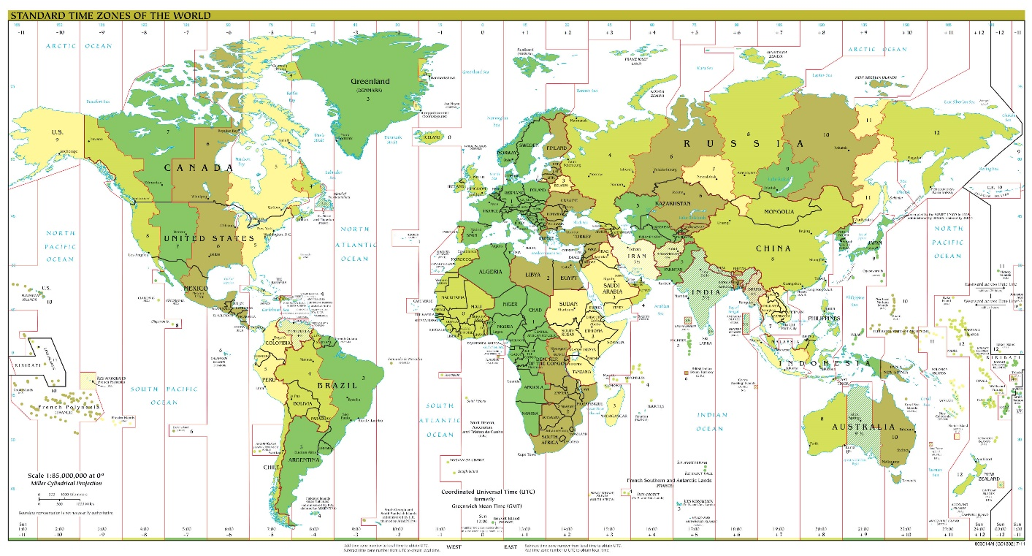
Displays and Special Events

Publications of big history.

Conference Logos

The symbol for our conference, Changing the World, embodies the four-fold aspects of Big History – Cosmos, Earth, Life, Humanity – represented by the moon and sky, tree and leaves, trail tracks, and ground. all in a kind of yin / yang representation of nature / harmony. In the grooves of the tree bark are the Japanese kanji for yasumu. Yasumu means rest, and joy. It is an ancient and complex imagery, being made up of 人 hito - humans and 木 ki - tree. The combined kanji symbols for people show they are supporting each other beneath a tree. It reminds us that to change the world, we must acknowledge that change comes from engagement, mutualization and symbiosis with each other and with nature, around the world and in the multiverse.

Appreciation to Yoshihiro Takishita of Kamakura, Japan for the concept and ideas and
to our artist, Ishikha Jain, of the Symbiosis School for Liberal Arts, Pune, Maharashtra.

Artist and graphic designer Nancy Crowe created this four-panel representation of Big History with geologist Walter Alvarez and IT designer Roland Saekow at the University of California Berkeley in 2010–2011. Her Big History tetraptych represents the Cosmos, Earth, Life and Humanity.

Ecology Initiative / Conference Carbon-Pollution Offset

SSLA is committed to sustainable and innovative practices. As part of our Big History conference, we have established a programme to mitigate and offset the negative effects of greenhouse gas emissions, pollution and energy use generated by our efforts to meet together. We will be doing an energy audit, but have established an on-going project in Pune that will surpass the offset. We have partnered with the Society of Christ Jesus, a Catholic NGO in Pune, to develop soil, plant, water and wildlife rehabitation. We are working with the Sisters to set up a permaculture area on their large campus, which will be used in an ecology course for slum residents that the Sisters are developing with SSLA and ecology activists and technicians in Pune. The focus is to carry green development into slum communities, self-managed by the residents. This initiative will continue by SSLA’s social ecology programme and provide service-learning opportunities for students in future semesters. A book and online materials will be developed from this exciting effort!

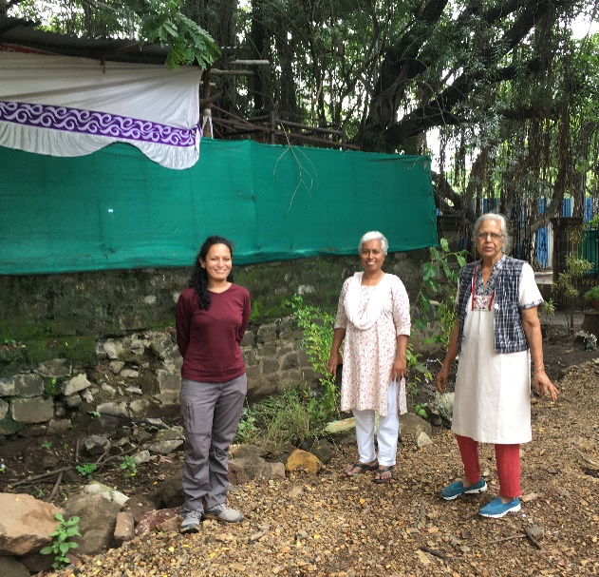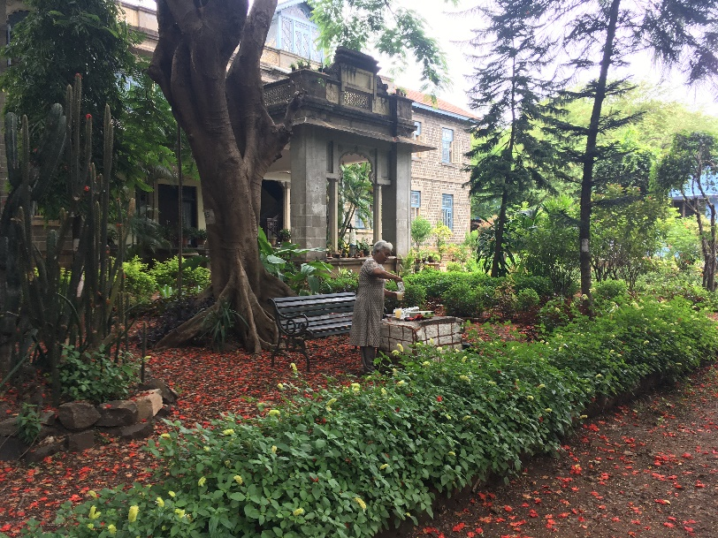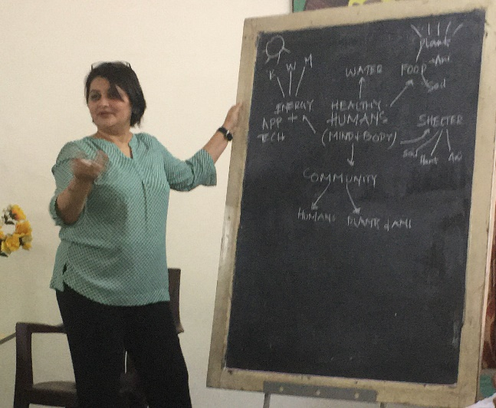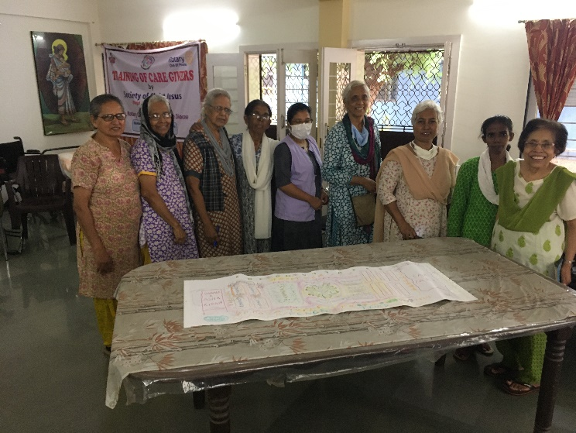
Childcare / Kids Events
We are planning a venue of childrens events that will involve play, dance, art, music, movies, stories and more. It will invove family interaction and help, but is designed to help parents to attend the conference. Children are also welcome to attend the main conference events too.

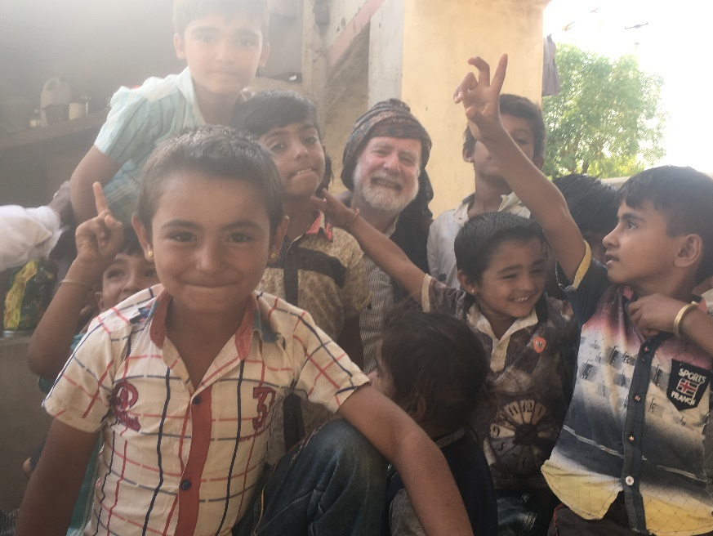
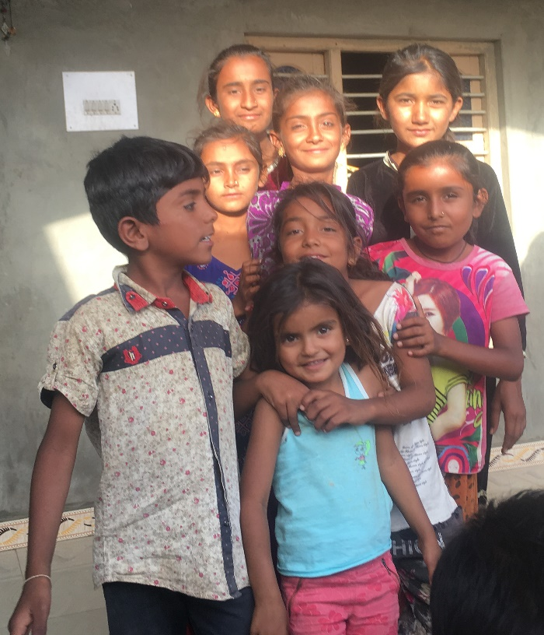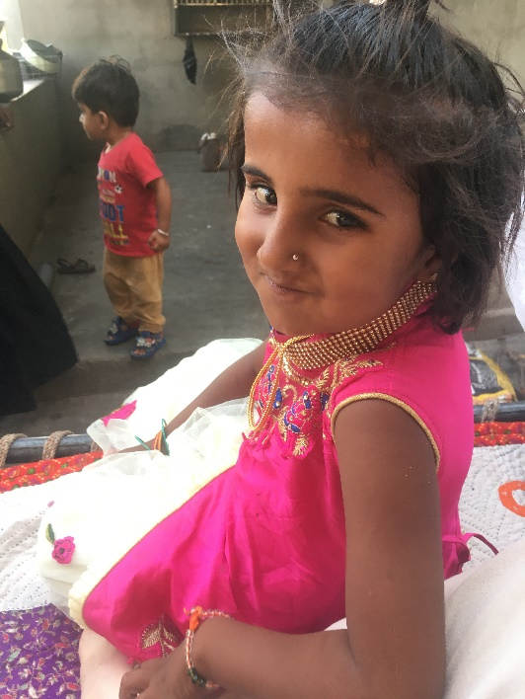

Kachchh Patthar

In celebration of our 2021 Big History Congress in India, SSLA and Kachchh Heritage Arts Music Information Resources in Kachchh <http://www.khamir.org/> will provide attendees with a handloom cotton scarf (patthar) decorated by Mansukhbhai Khatri. A Hindu artist, he is from the village of Bela and the last practitioner of Bela block-printing. His traditional designs use blocks that belonged to his grandfather, infusing each cloth in vegetable dye with a rustic, antique sensibility that echoes of times passed. In collaboration with Mansukhbhai, Khamir is working to reinvigorate Bela-style printing.

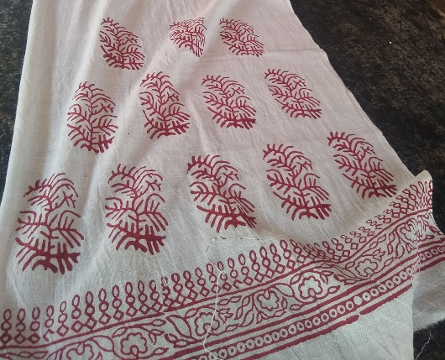

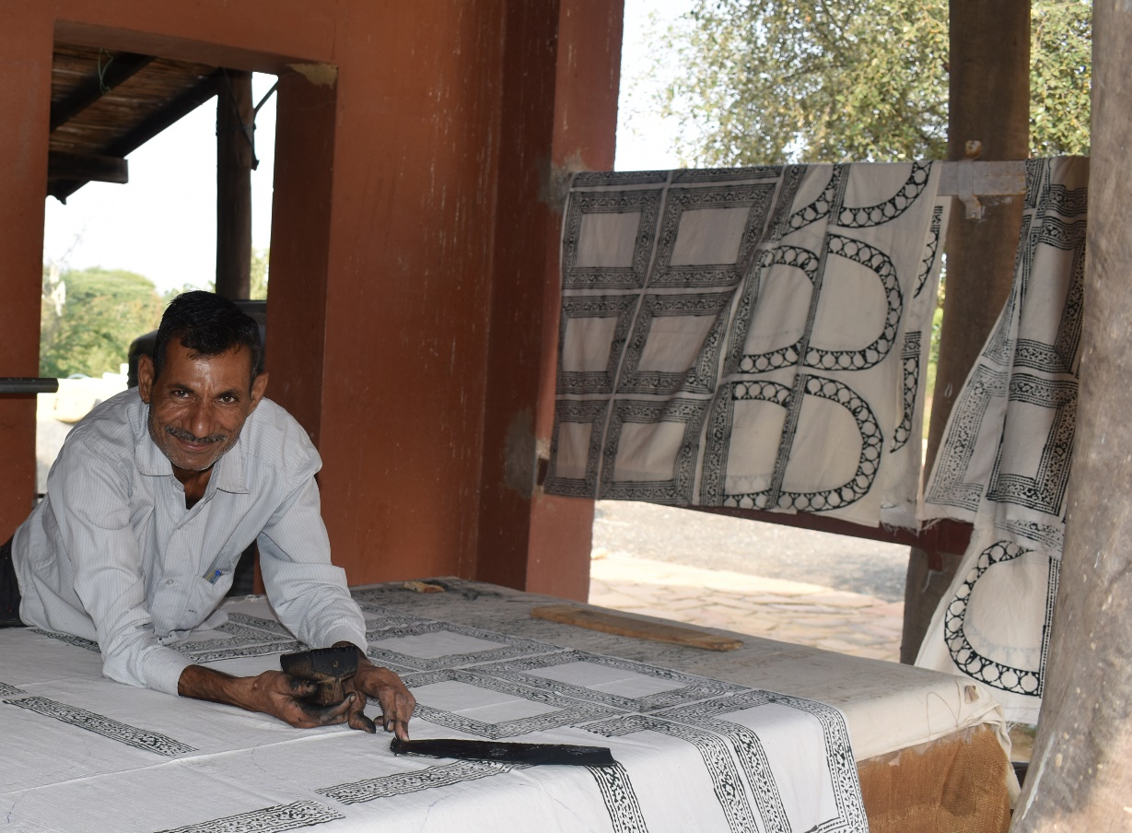
Post-Conference Seminars

On Thursday, August 5th, we will break into groups that will go to different parts of India for theme-based interactions. The seminars will take place Saturday to Sunday, August 7th through 9th. Each location can accommodate up to about 30 participants. Attendees will stay at a local organization that is active in local change-making and will learn about their activities, including visits to their field sites. There will also be visits to heritage sites and trekking in ecological areas, in addition to panel presentations by conference and local community members. See the 2021 Big History Conference webpages to learn more and sign up for a seminar <bighistory.org>. The seminars that we have arranged with host organizations are as follow.

Science & Changing Society
Homi Bhabha Centre for Science Education
Tata Institute for Fundamental Research
Mumbai, Maharashtra: <www.hbcse.tifr.res.in>

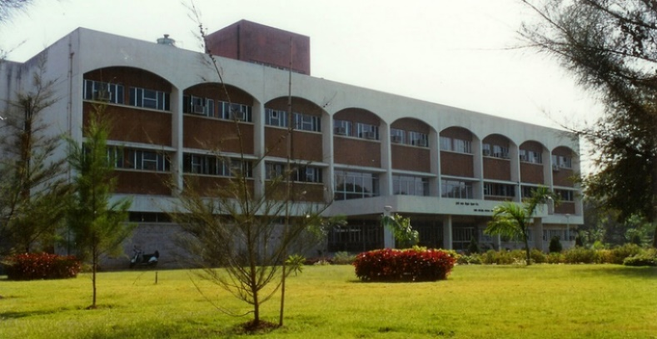

\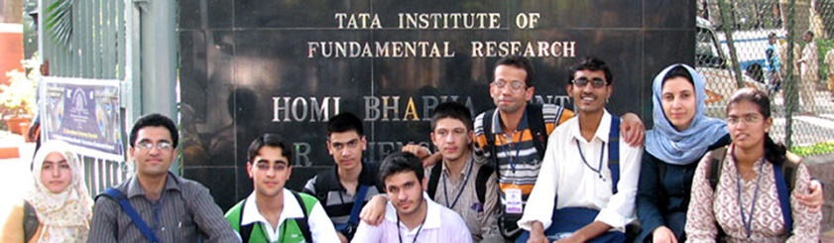

Landscape & Adapting Heritage
Kachchh Heritage Arts Music Information Resources: Khamir
Kutch, Gujurat <http://www.khamir.org/>

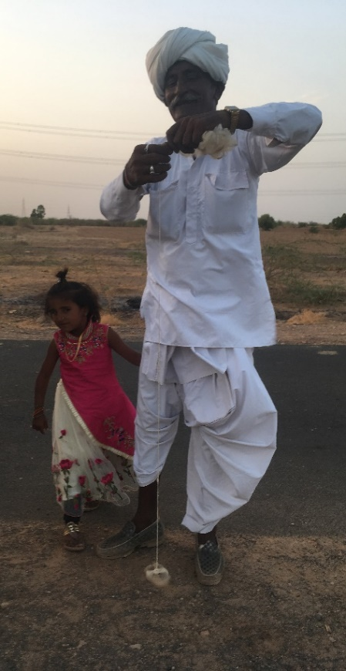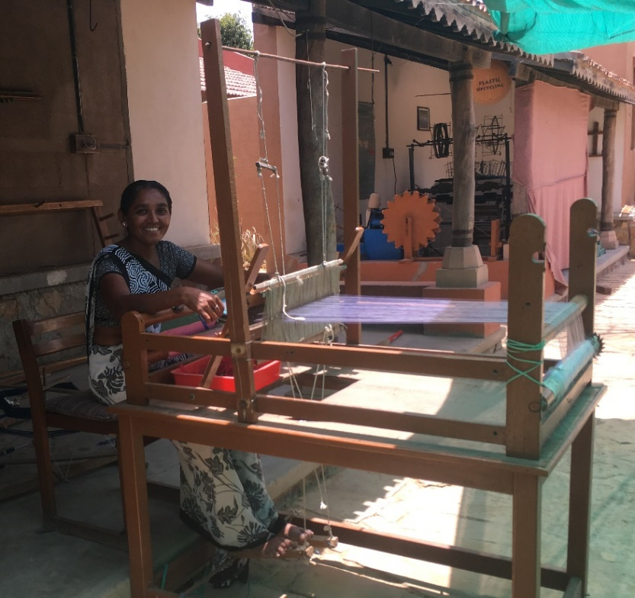
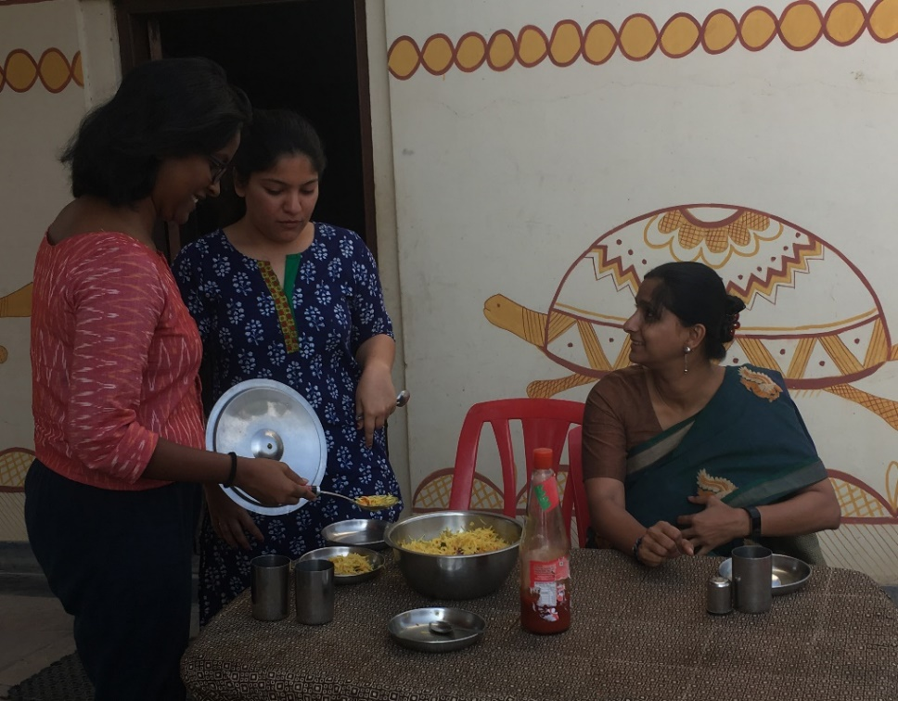

Agrarian Life & Renewal
Tarumitra: Friends of Trees
Patna, Bihar <http://tarumitra.org/>

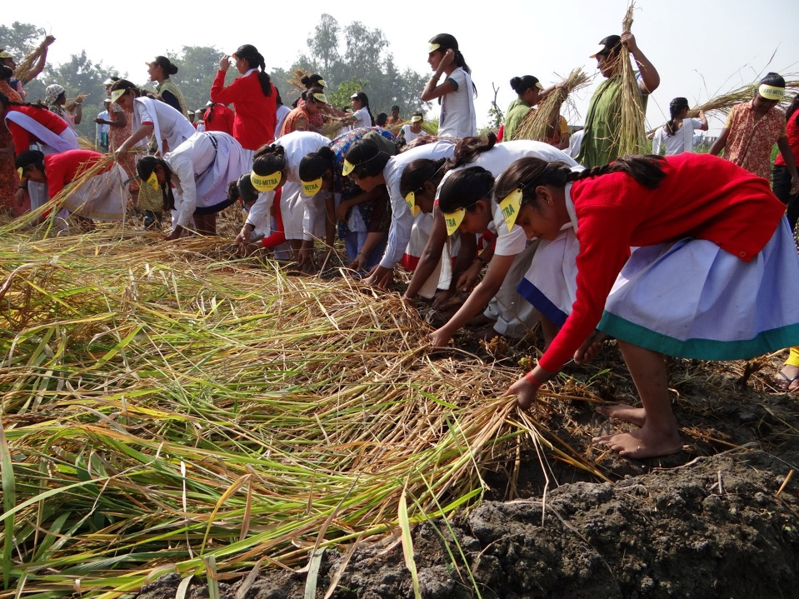

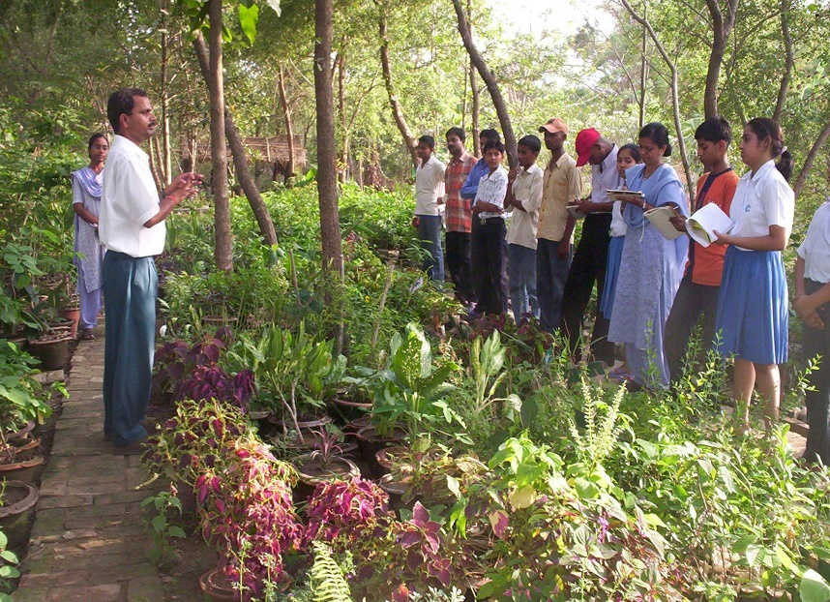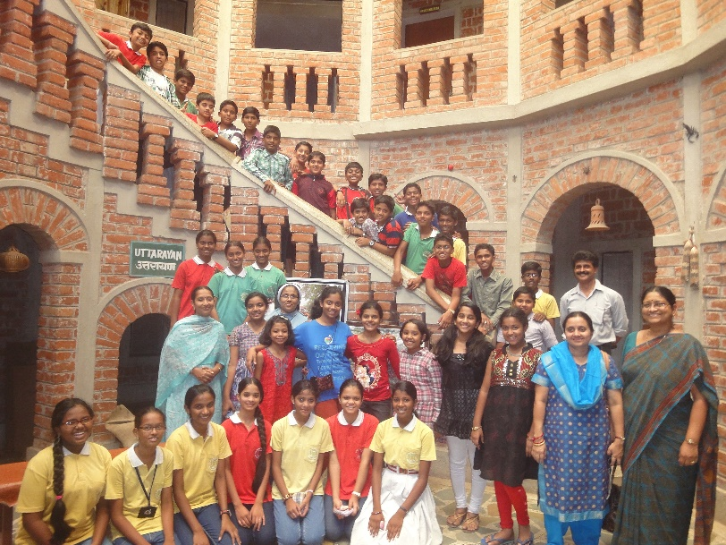

Indigenous-Tribal Heritage & Innovation
All-India Indigenous-Tribal Federation
Guwahati, Assam <https://tinyurl.com/AITF-org>

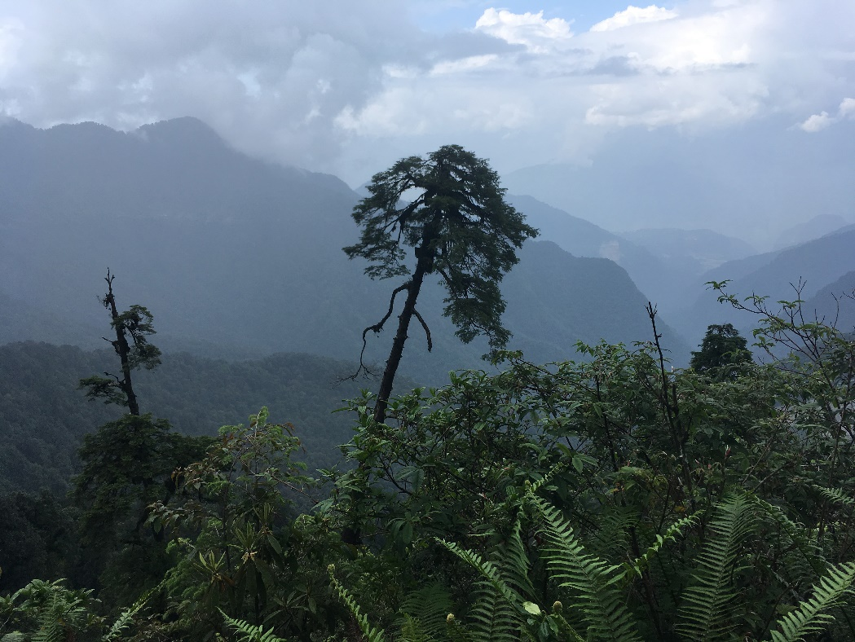

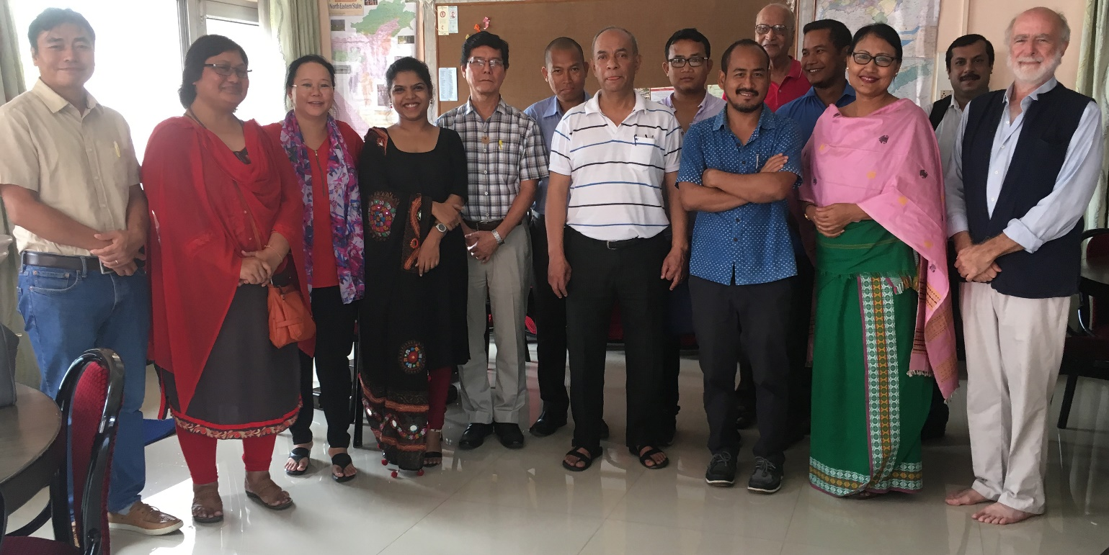

Eco-Spirituality & New Global Needs
Fireflies Intercultural Centre
Bengaluru, Karnataka <www.pipaltree.org.in>

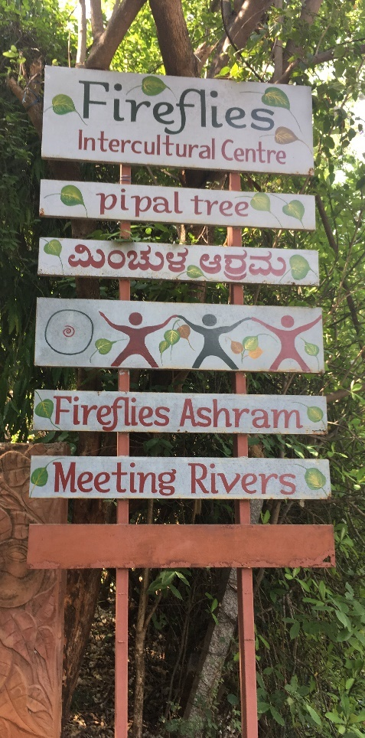

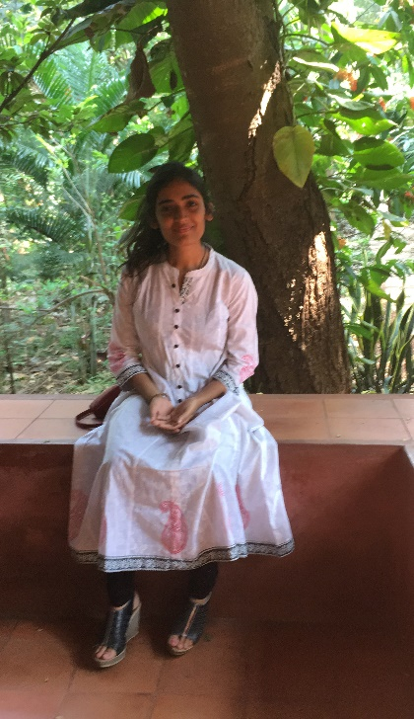

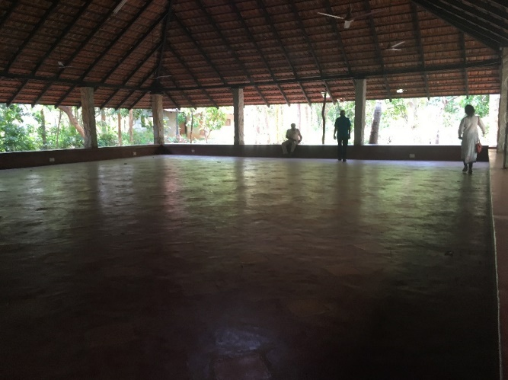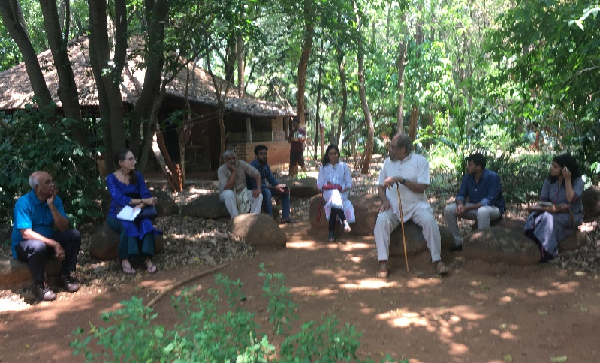

Gender, Environment & Social Transformation
JAS – Society for People’s Initiatives
Simla District, Himachal Pradesh <www.jasindia.org>

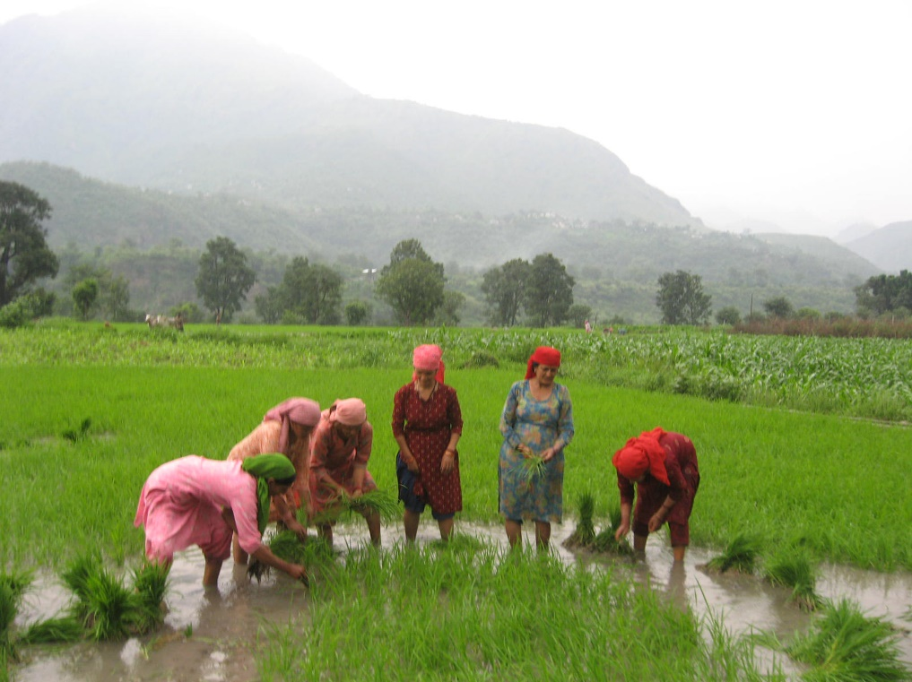

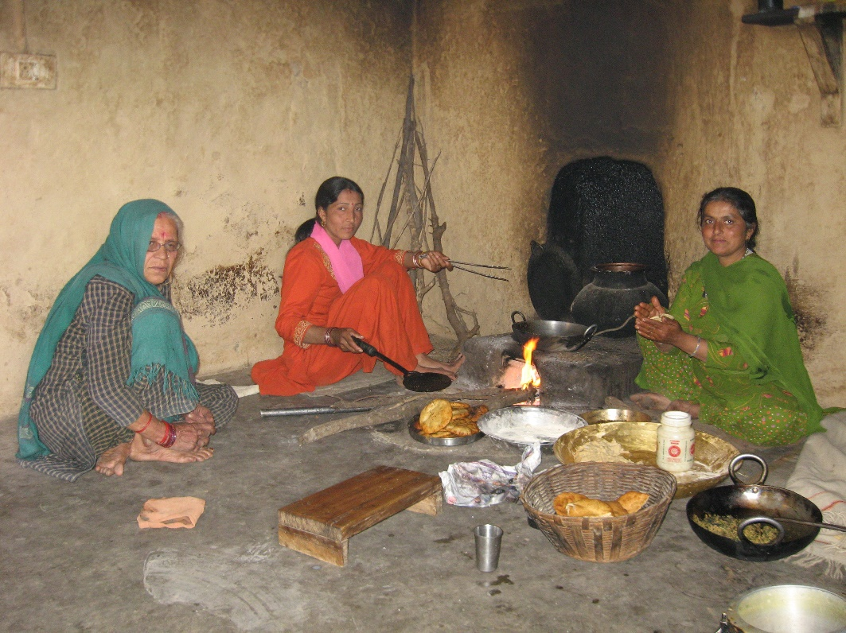

Conference Committees

General Conference Coordinator
Barry Rodrigue
with Oishika Neogi

SSLA
Anita Patankar (Director)
Shweta Sinha Deshpande
Richa Minocha

IBHA
Lowell Gustafson (President)
Lucy Laffitte
David Blanks

Asian Big History Association
Nobuo Tsujimura (President)
Katayama Hirofumi
Sun Yue
Jahnavi Pandya

Indian Association of Big History
Shweta Sinha Deshpande (President)
Priyadarshini Karve
Afshan Majid

International Community Organizers
Sulakshana Sen
Midori and Dan Batten
Orla Hazra
Vandana Singh

SSLA Student Teams
Student Coordinators
Tanvi Singh
Vedanti Poddar

Marketing Team
Manavi Pandey (coordinator)
Harini Ruparel
Isha Banerjee
Mathew Mammen
Prerna Chakraborty

Communications / Media Team
Diviya Makhija (coordinator)
Aena Asif
Diya Mathur
Ishika Paruthi
Kulsimran Bedi
Mayurika Das
Ria Wadikar
Simran Sood
Soujanya Bhattacharyya

Logistics Team
Kashish Gupta (coordinator)
Ahaan Azavedo
Amarabati Bhattachharya
Ananya Moorthy
Atreyi Mitra
Diti M.
Gunjan Periwal
Misinam Mize
Naushi Mathur
Ruchira Paul
Ruthu Ganesh

Creative & Design Team
Ishika Jain (coordinator)
Purvi Prajapati
Sanjana Shetty
Tishya Kacker
Trisha Nair

Ecology Team
Sudev Madhav (coordinator)
Dhwani Shrotriya
Karthik Anil Kumar
Onam Wadhwa

IT Team
Mahak Jain (coordinator)
Archi Kulkarni
Ganya Narang
Muskaan Narvani
Sharika Bhan

